|  |  |  |  |  |  |
| --- | --- | --- | --- | --- | --- |
|  |  | | | | |
|  | |  | | | |
| Project Topic: | | Comparison of KNN Implementation in Python v/s WEKA Implementation of KNN | | | |
| Module: | | Project Report | | | |
| Deliverable:  Course: | | Programming Assignment 1  CSE 6363-004 - Fall 2020 | | | |
| Version: | | | [1.0] | Date: | [09/18/2020] |

Prepared by:

Rahaman, Fahad Ur (Student ID: 1001753107)

TABLE OF CONTENTS

1. KNN IMPLEMENTAION - PYTHON 2

1.1 DETAIL EXPLANATION 2

1.2 SCREENSHOTS OF IMPLEMENTATION 3

2. KNN IMPLEMENTAION - WEKA 9

2.1 DETAIL EXPLANATION 9

2.2 SCREENSHOTS OF IMPLEMENTATION 10

3. COMPARISON OF ACCURACY RESULTS 29

REFERENCES 30

# 1. KNN IMPLEMENTATION - PYTHON

## 1.1 Detail Explanation: K-Nearest Neighbors Implementation in python from scratch

In Order to Implement KNN Algorithm, we must follow the below 3 STEPS:

* We Need to calculate the Distance Measure (e.g.: Euclidean, Manhattan, etc.)
* We Need to then identify the nearest neighbors
* Make Predictions based on Majority of Neighbors

In Our Implementation of K-Nearest Neighbors in Python, we have followed the below steps:

* Firstly, we load the dataset using “load_csv()”
* Convert the loaded data to numbers that we can use with the mean and standard deviation calculations with the help of helper functions “str_column_to_float()” to convert string numbers to floats and “str_column_to_int()” to convert the class column to integer values
* Find the minimum and maximum values and then rescale/normalize the columns of the dataset to range between 0-1
* We make use of “get_neighbors” function to identify the similar neighbors based on k value and “predict_classification” function to make predictions
* Finally, we will evaluate the algorithm using k-fold cross-validation with 10 folds. This means that Dataset Size/10=K records will be in each fold [i.e. Car dataset = 172.8, Breast Cancer dataset = 28.6, Hayes-Roth = 13.2 records in each fold]. We will use the helper functions “evaluate_algorithm()” to evaluate the algorithm with cross-validation and “accuracy_metric()” to calculate the accuracy of predictions

Below are the Screenshots of code implemented in python and the enhancements made to increase accuracy of the model by fine tuning the ‘k’ parameter and by applying different distance measures

Please find the complete implementation of the python code in “[Programming Assignment 1 - CSE 6363-004_FAHAD UR RAHAMAN.ipynb](http://localhost:8888/notebooks/Programming%20Assignment%201%20-%20CSE%206363-004_FAHAD%20UR%20RAHAMAN.ipynb)”

## 1.2 SCREENSHOTS OF IMPLEMENTATION OF KNN, K-FOLD CV IN PYTHON FROM SCRATCH

#### Dataset = "Hayes-Roth", K = 3, Distance = "Euclidean", Cross Validation = 10

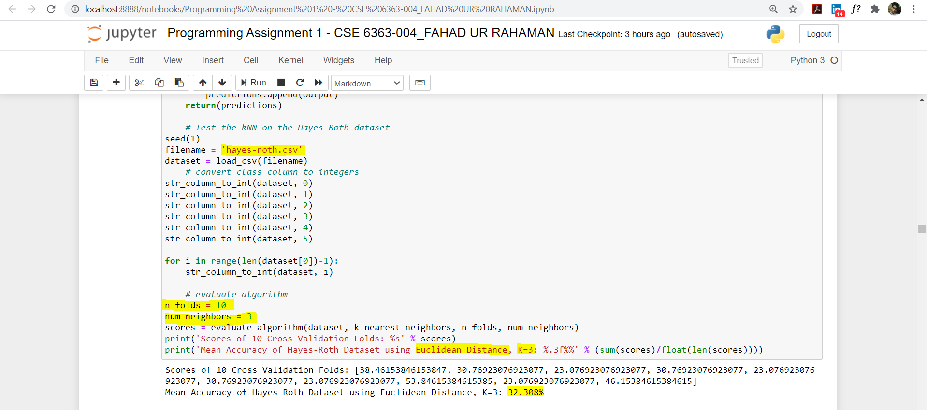

#### Dataset = "Hayes-Roth", K = 5, Distance = "Hamming", Cross Validation = 10

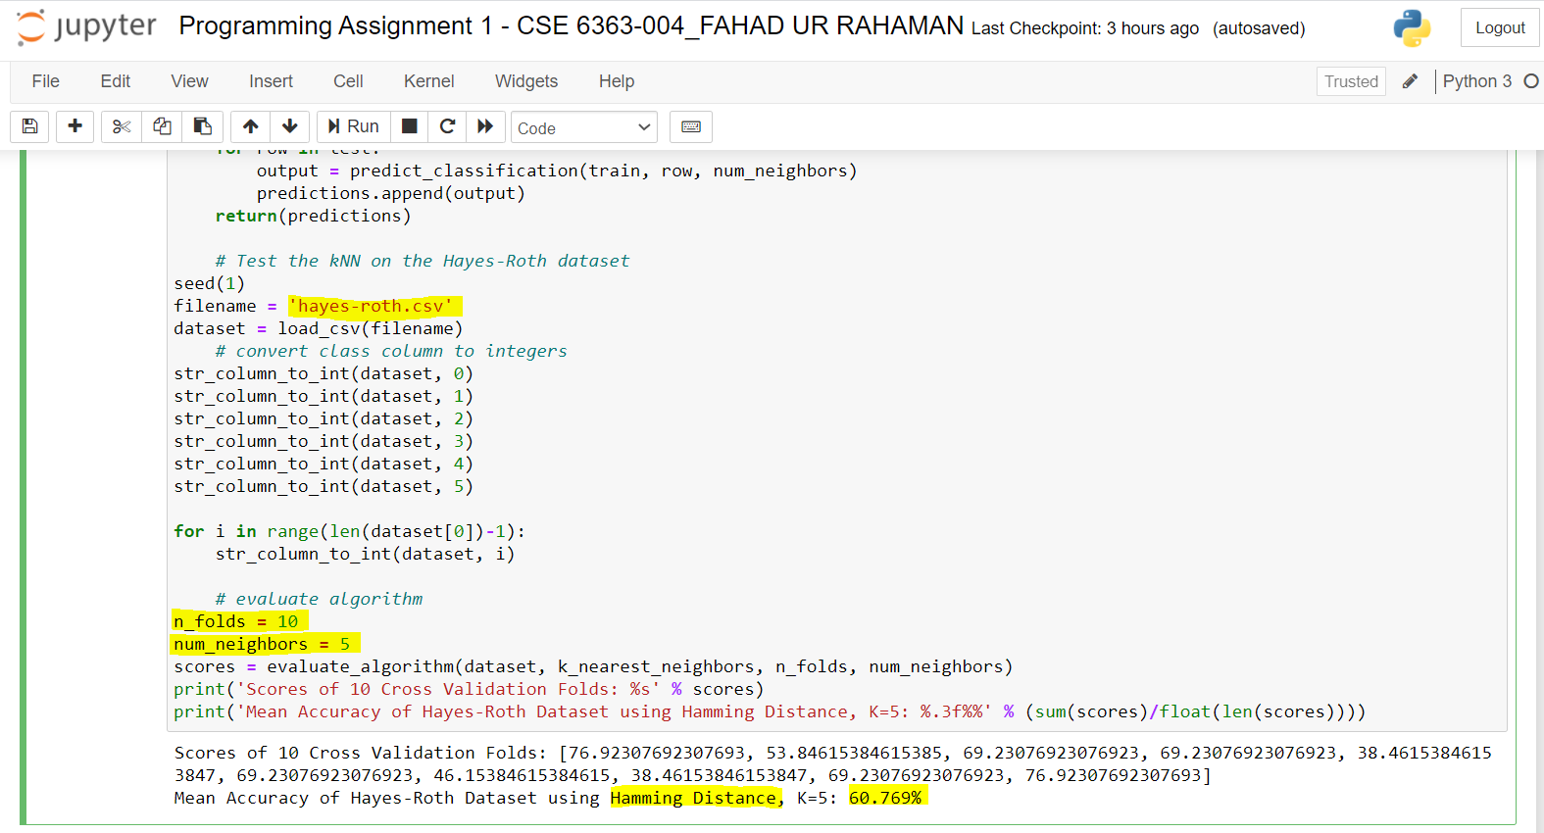

#### Dataset = "Hayes-Roth", K = 11, Distance = "Manhattan", Cross Validation = 10

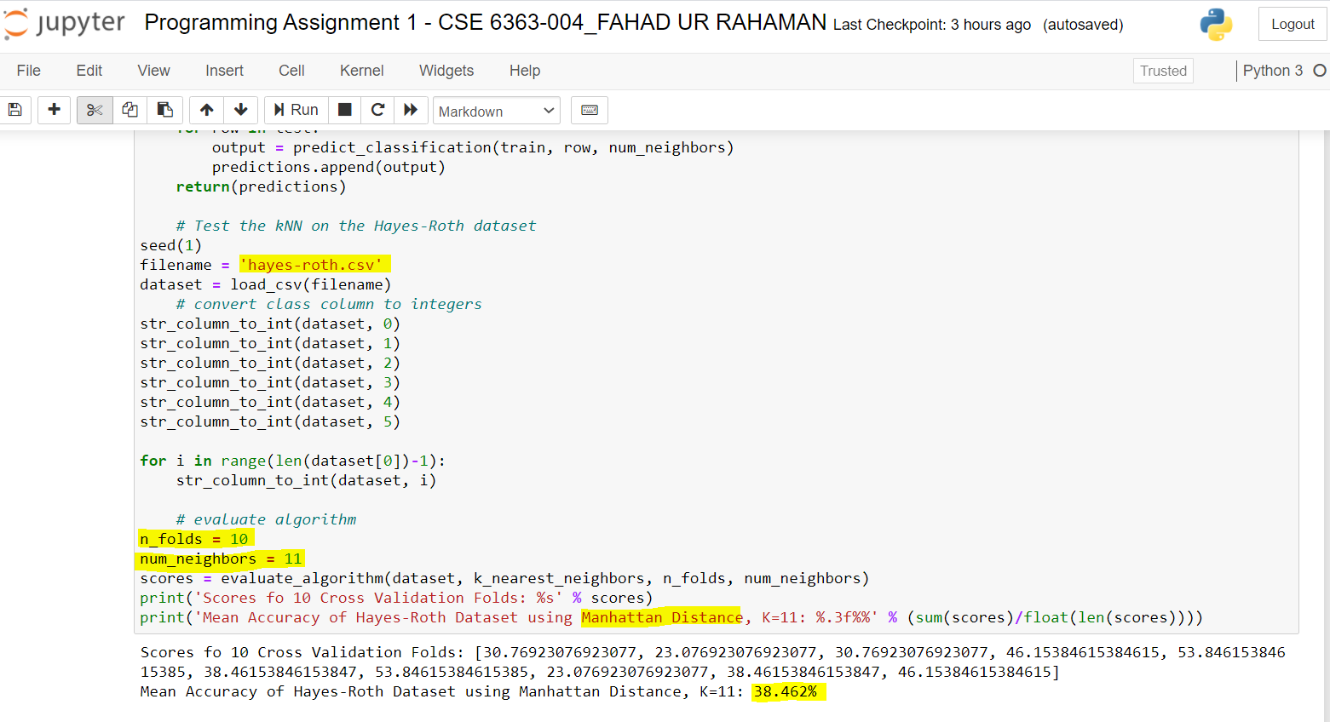

#### Dataset = "Hayes-Roth", K = 13, Distance = "Jaccard Similarity", Cross Validation = 10

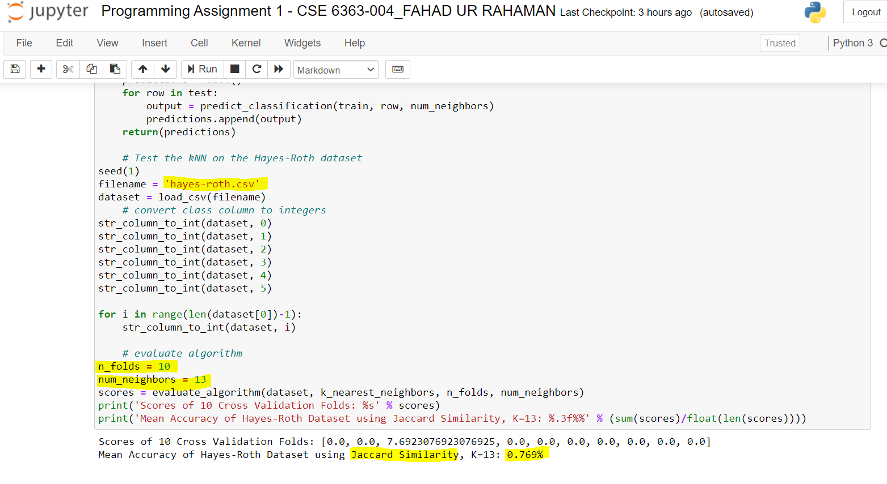

#### Dataset = "Car Evaluation", K = 3, Distance = "Euclidean", Cross Validation = 10

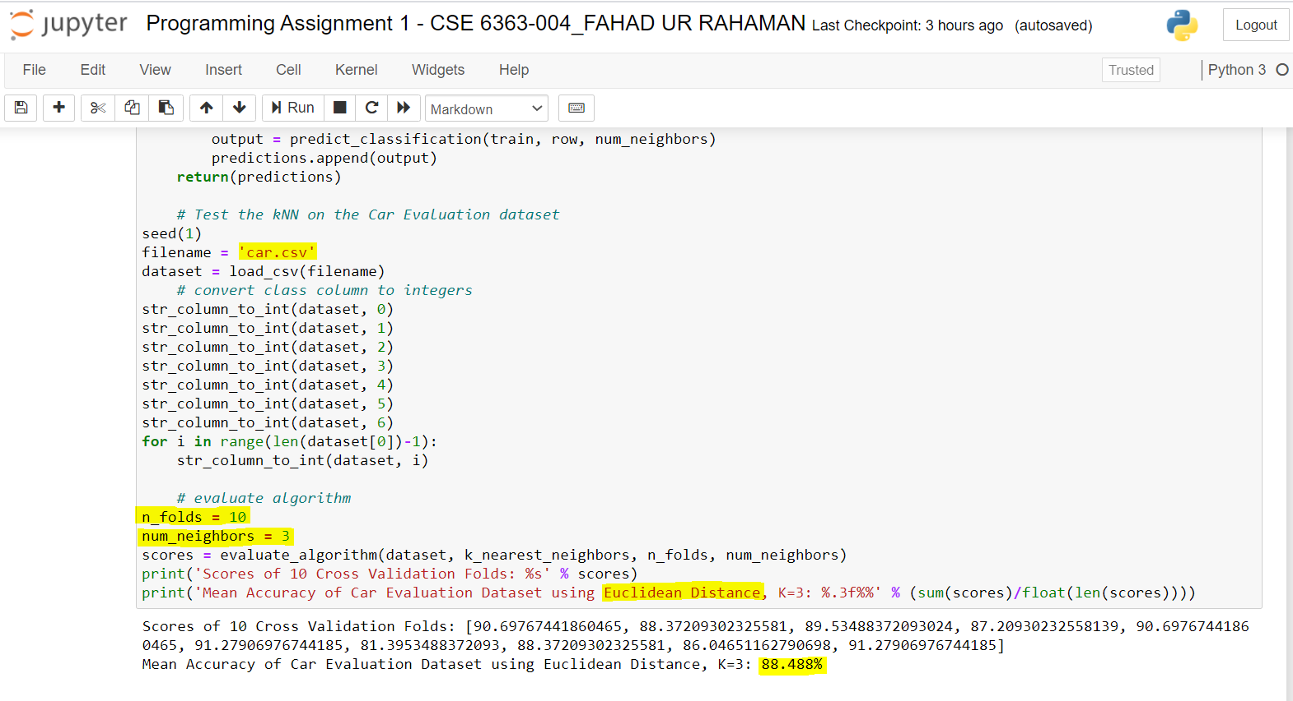

#### Dataset = "Car Evaluation", K = 5, Distance = "Hamming", Cross Validation = 10

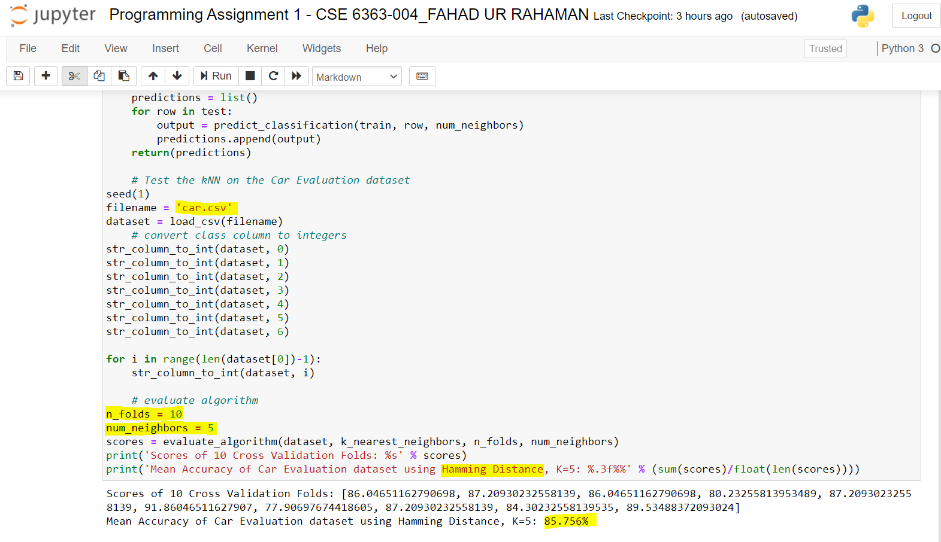

#### Dataset = "Car Evaluation", K = 11, Distance = "Manhattan", Cross Validation = 10

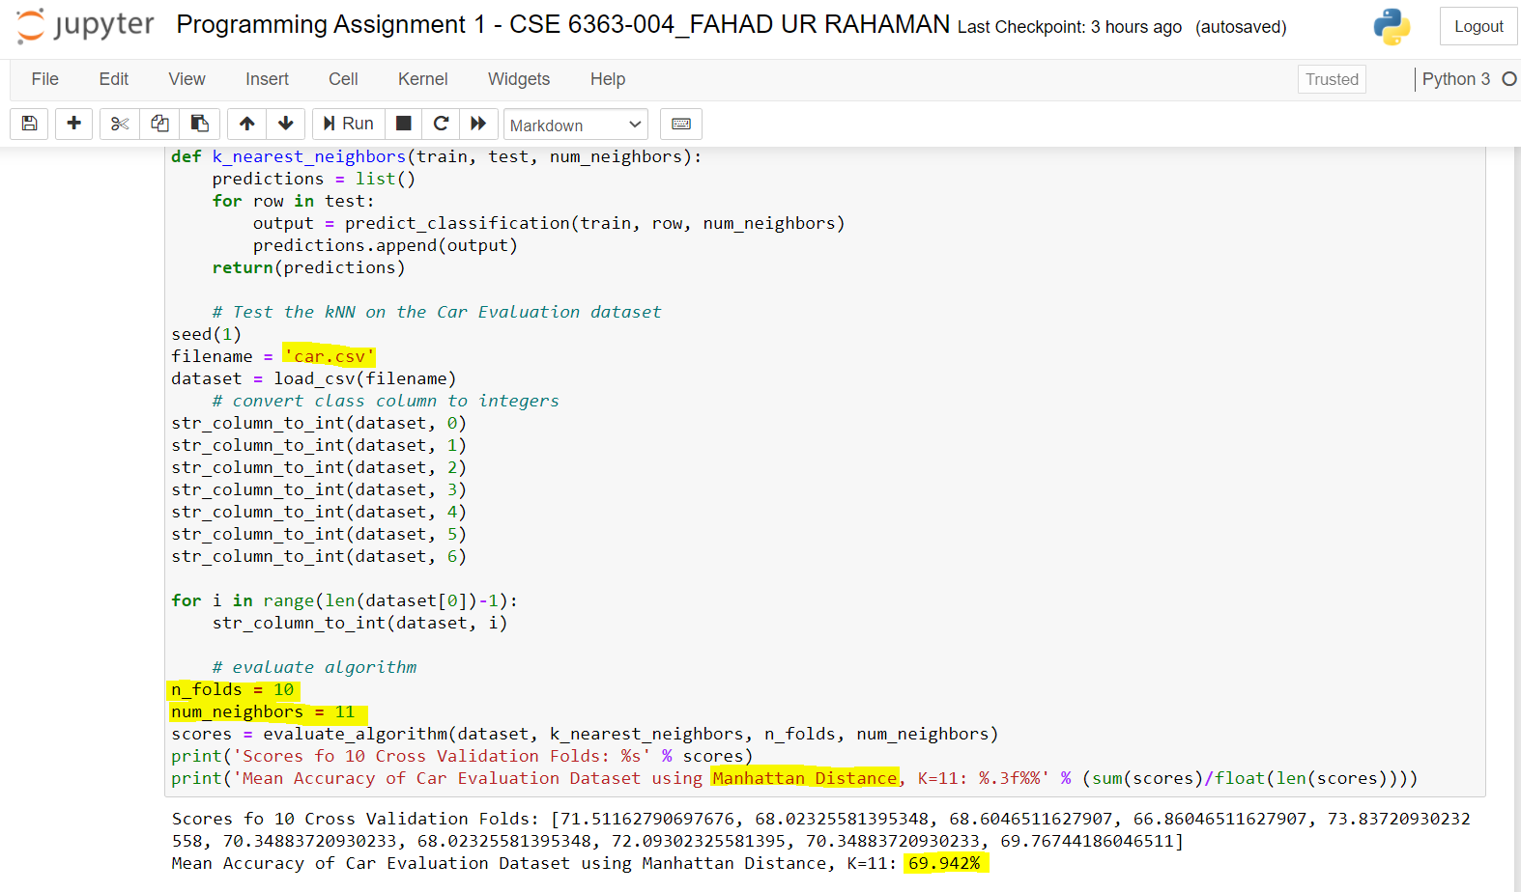

#### Dataset = "Car Evaluation", K = 7, Distance = "Jaccard Similarity", Cross Validation = 10

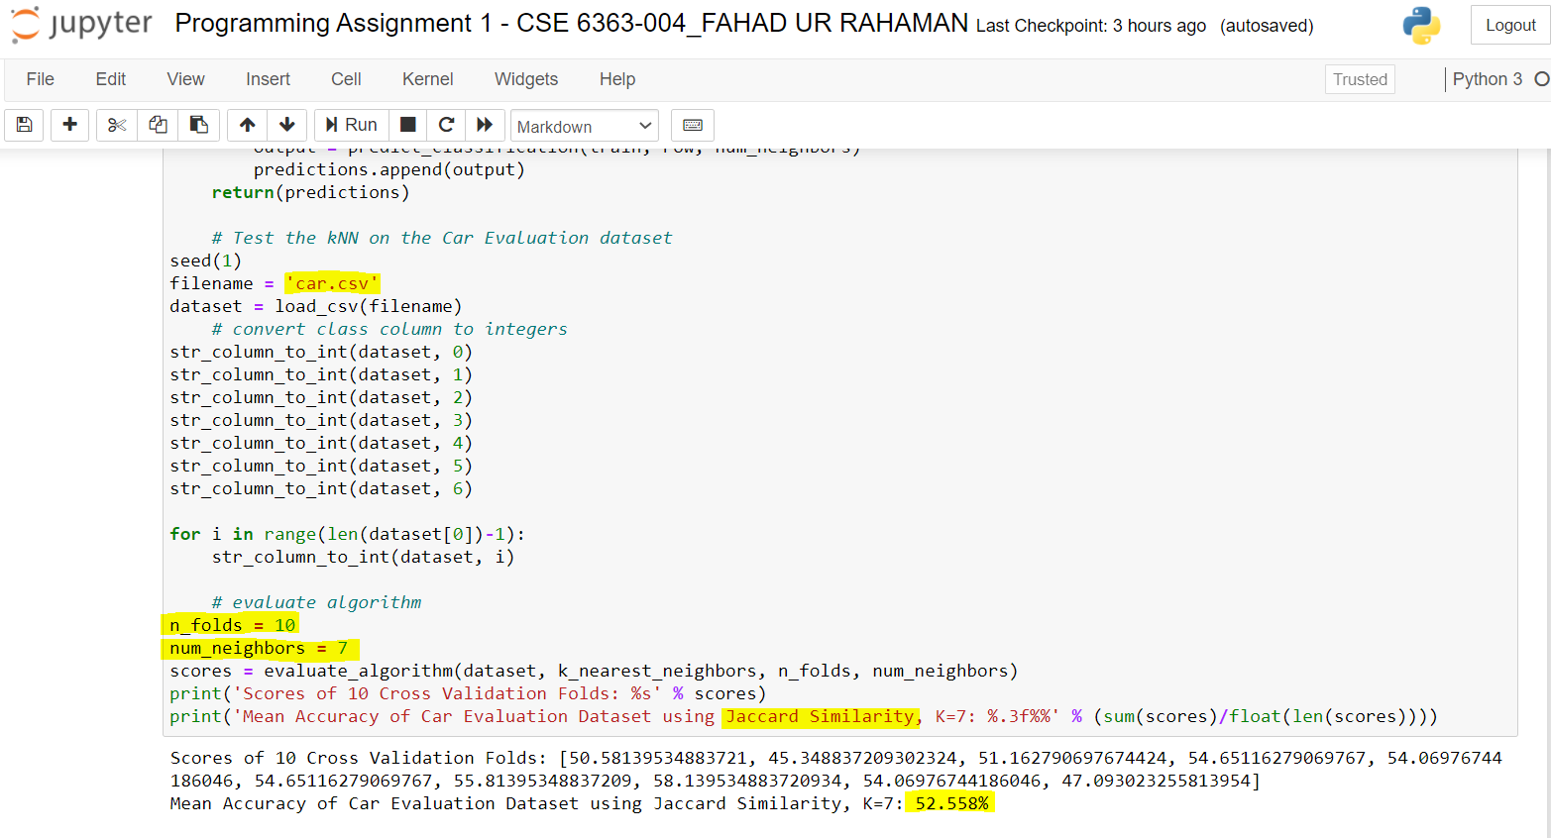

#### Dataset = "Breast Cancer", K = 11, Distance = "Euclidean", Cross Validation = 10

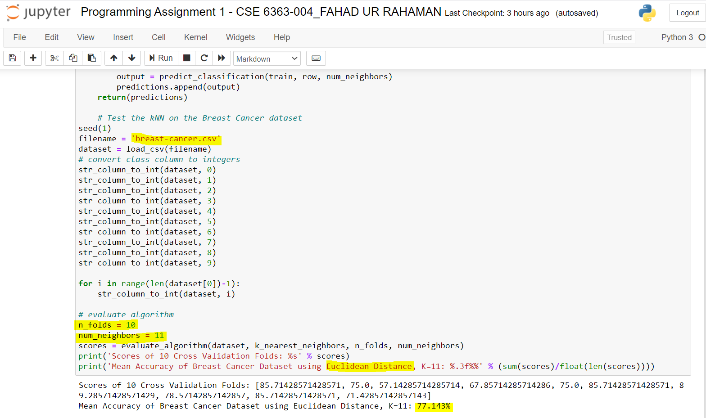

#### Dataset = "Breast Cancer", K = 13, Distance = "Hamming", Cross Validation = 10

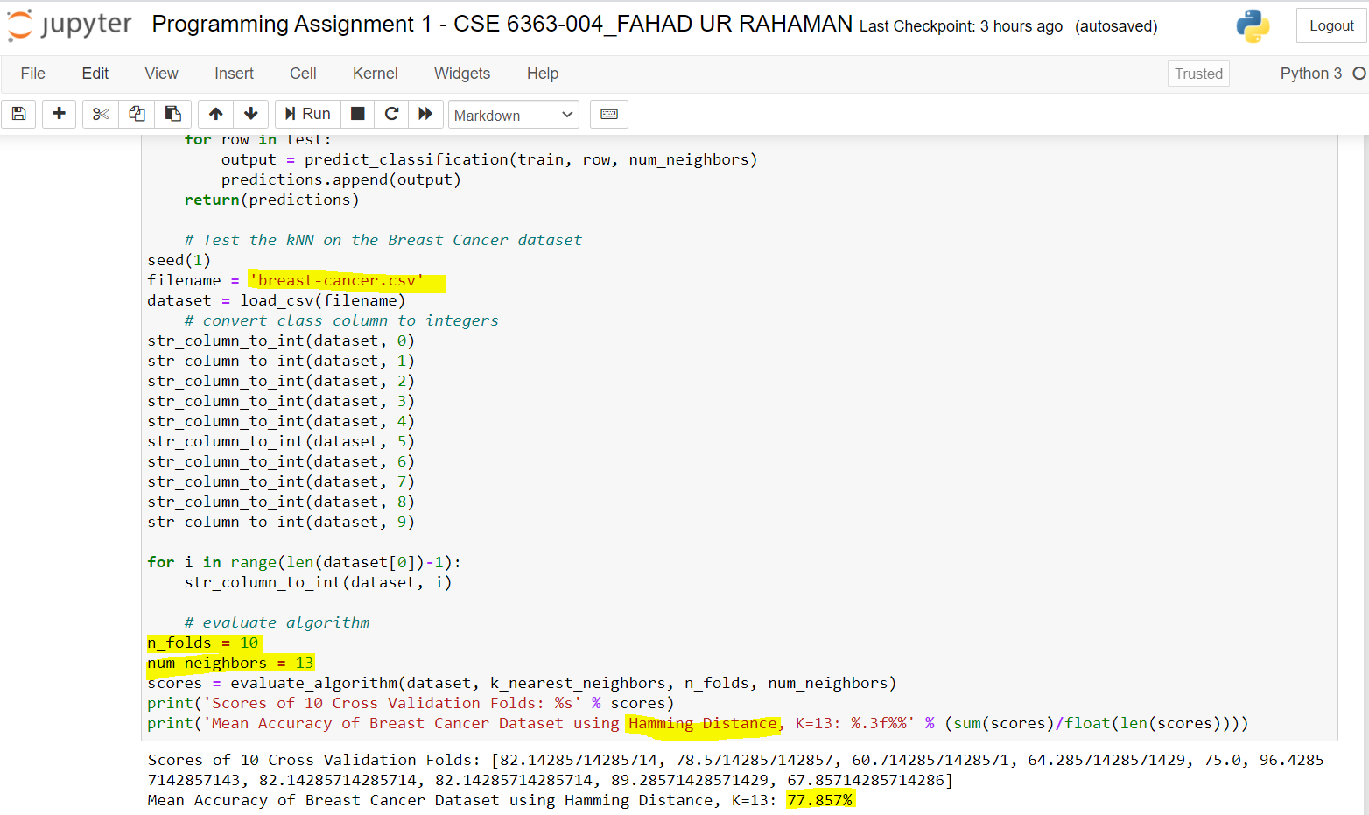

#### Dataset = "Breast Cancer", K = 11, Distance = "Manhattan", Cross Validation = 10

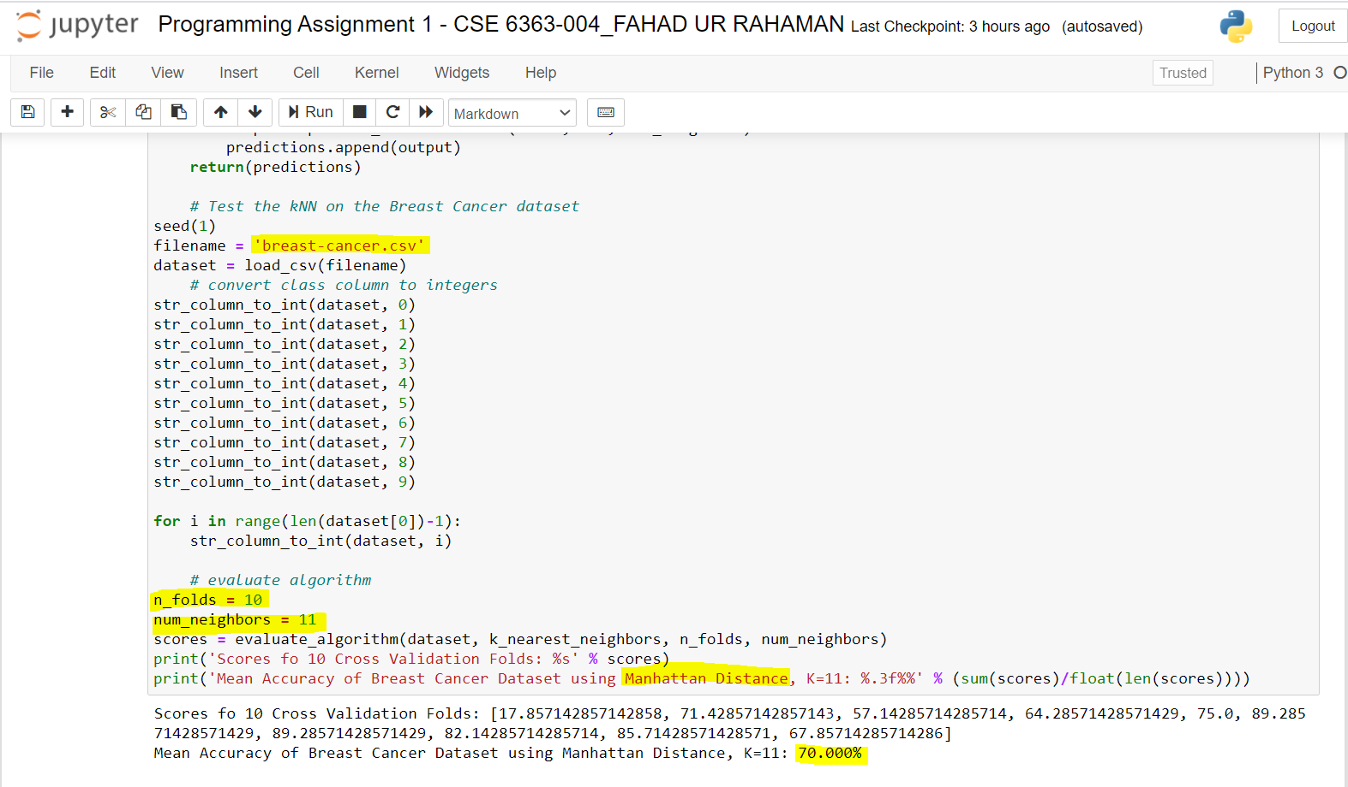

#### Dataset = "Breast Cancer", K = 15, Distance = "Jaccard Similarity", Cross Validation = 10

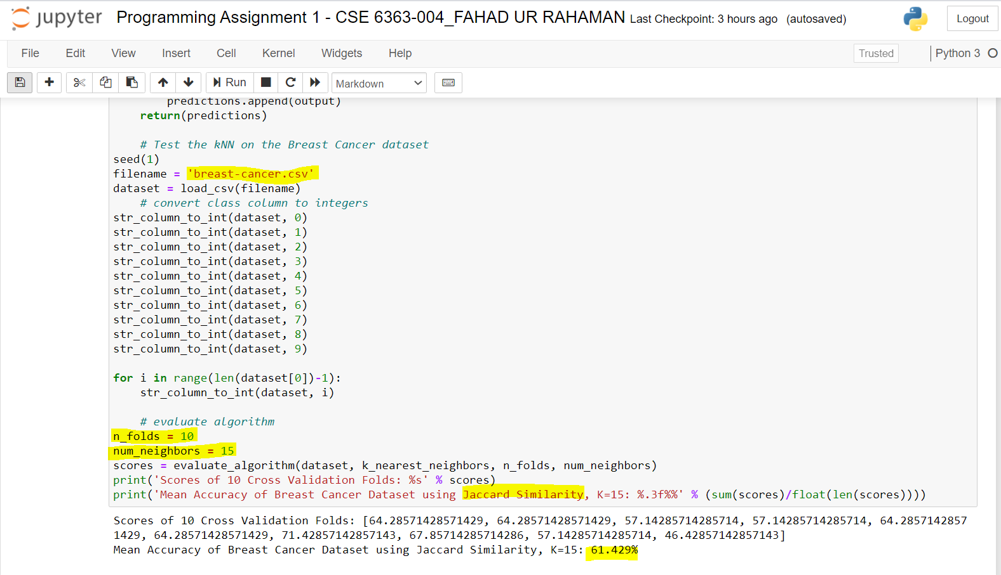

# 2. KNN IMPLEMENTATION - WEKA

## 2.1 Detail Explanation: K-Nearest Neighbors Implementation in WEKA

Below is the list of steps followed for KNN, K-Fold CV Implementation in WEKA:

* Downloaded the .data file for each dataset from UCI Machine Learning Repository
* Opened the .data file in Microsoft excel and added the header with the relevant attribute names separated by commas
* Saved the file in .csv format as WEKA only able to load files in .arff or .csv format
* Opened the dataset file in WEKA and selected the preprocess tab to visualize the data, preprocess data using relevant filters
* Selected Classify tab and chose Classifier from lazy 🡪 IBk and then chose K value and distance function (viz. Manhattan, Euclidean, etc.)
* Also, modified the evaluation metrics and selected the relevant metrics for data evaluation by going to test options 🡪 more options 🡪 evaluation metrics
* Finally, chose the relevant test option, chose the class as target class and clicked on the start button

## 2.2 SCREENSHOTS OF IMPLEMENTATION OF KNN, K-FOLD CV IN WEKA

#### CAR EVALUATION DATASET

#### PRIOR DATA PRE-PROCESSING – CAR EVALUATION DATASET

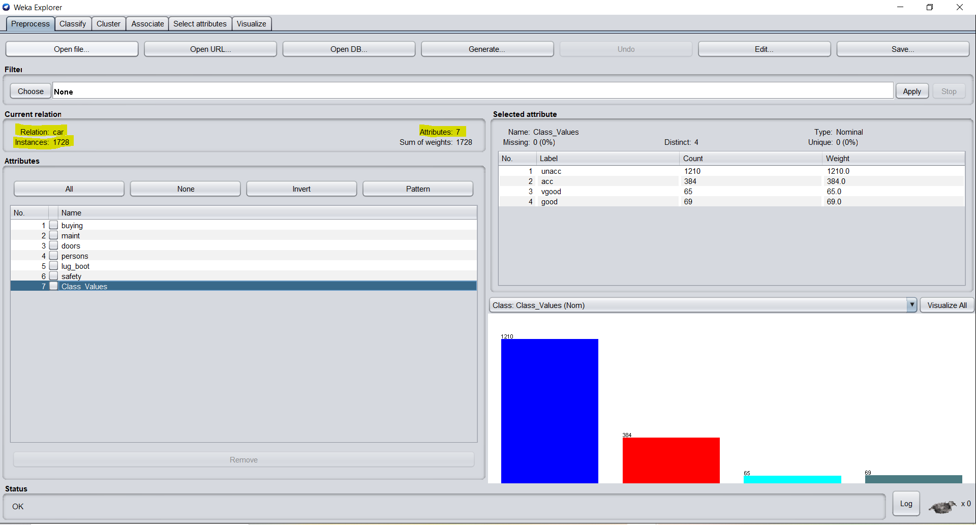

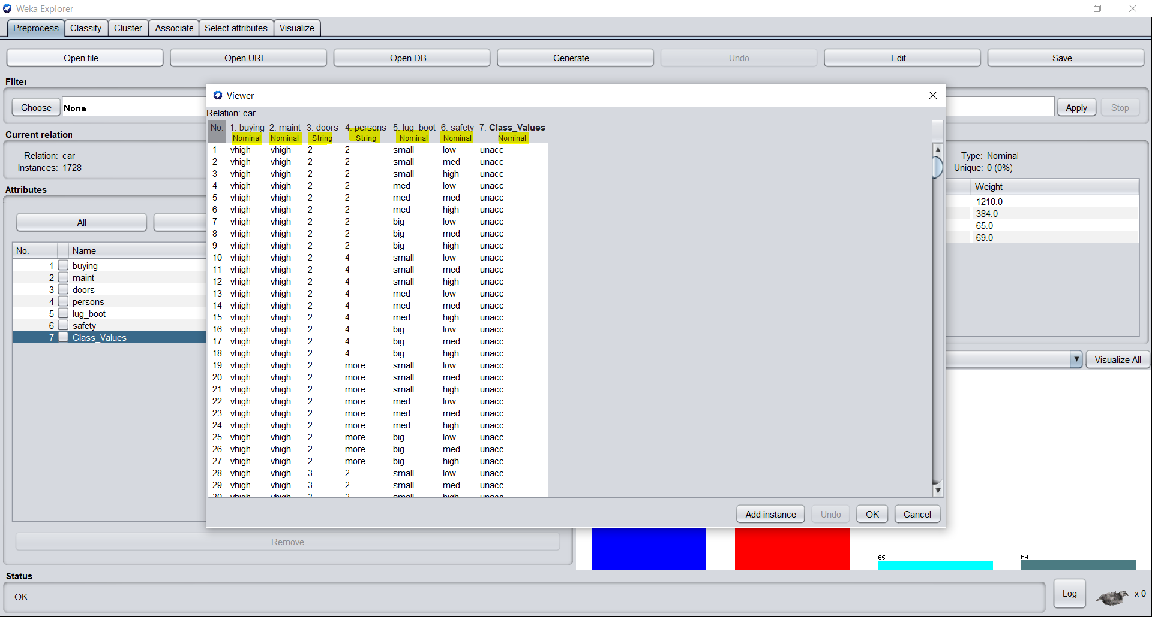

#### AFTER PREPROCESSING – CAR DATASET (Weka)

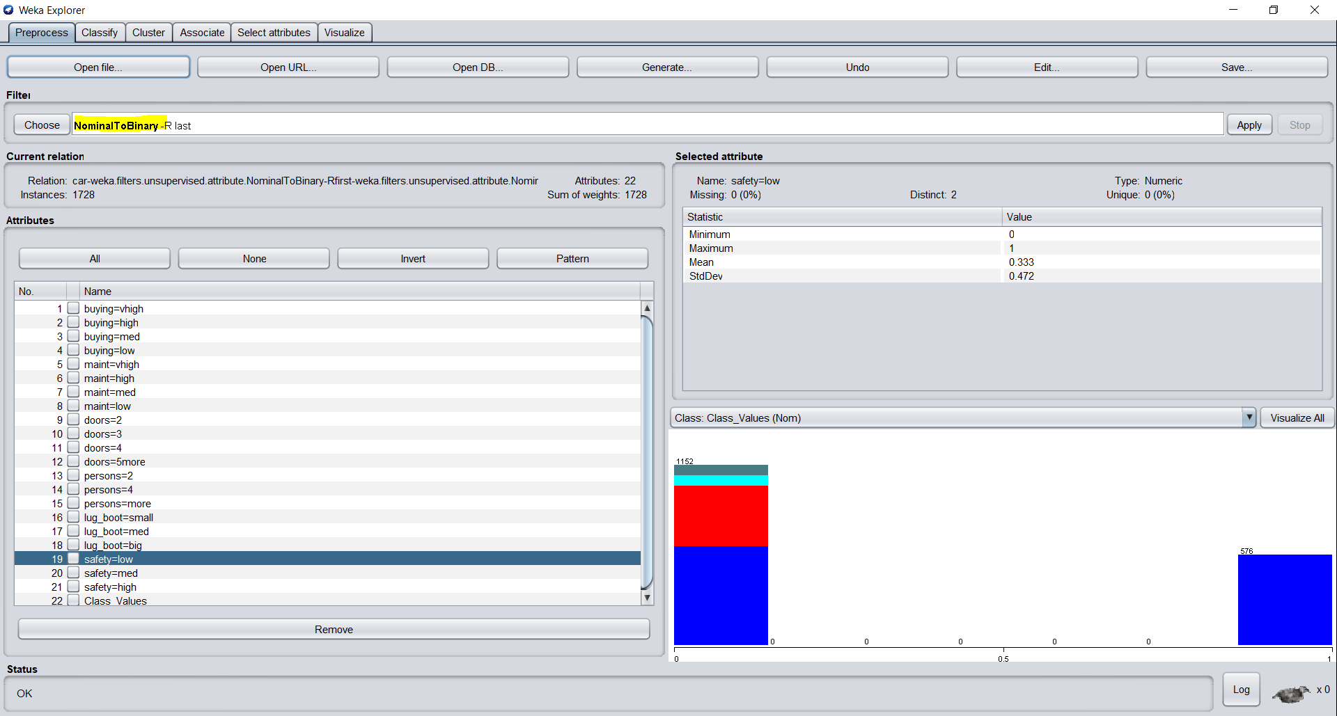

#### DATA HAS BEEN CONVERTED TO BINARY from NOMINAL By APPLYING FILTERS: “StringtoNominal” and “NominaltoBinary”

#### DATASET HAS BEEN CONVERTED TO NUMERIC NOW

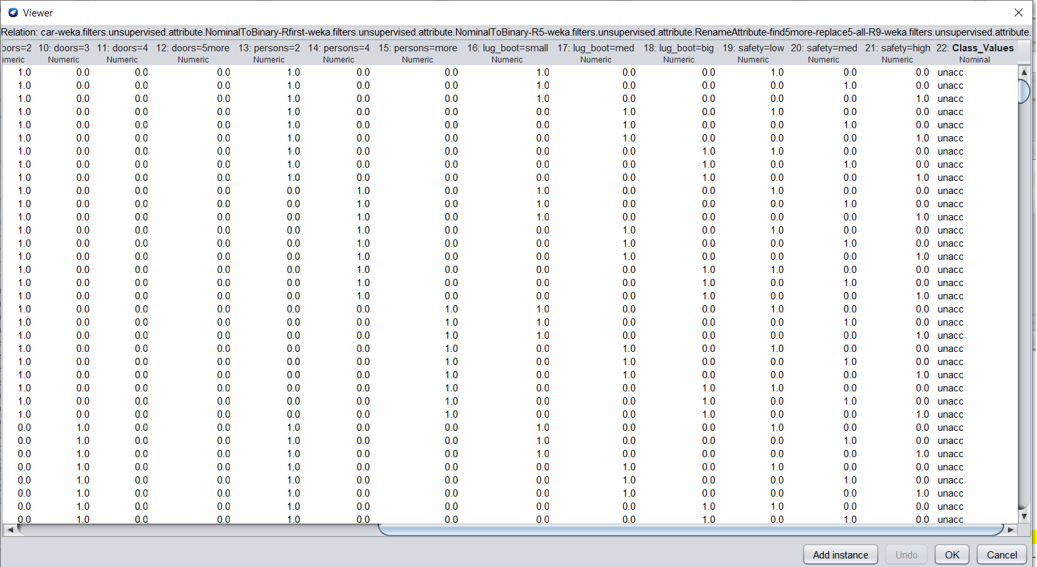

#### CAR EVALUATION DATASER WITH Rows = 1728, Columns =22 (After Pre-Processing)

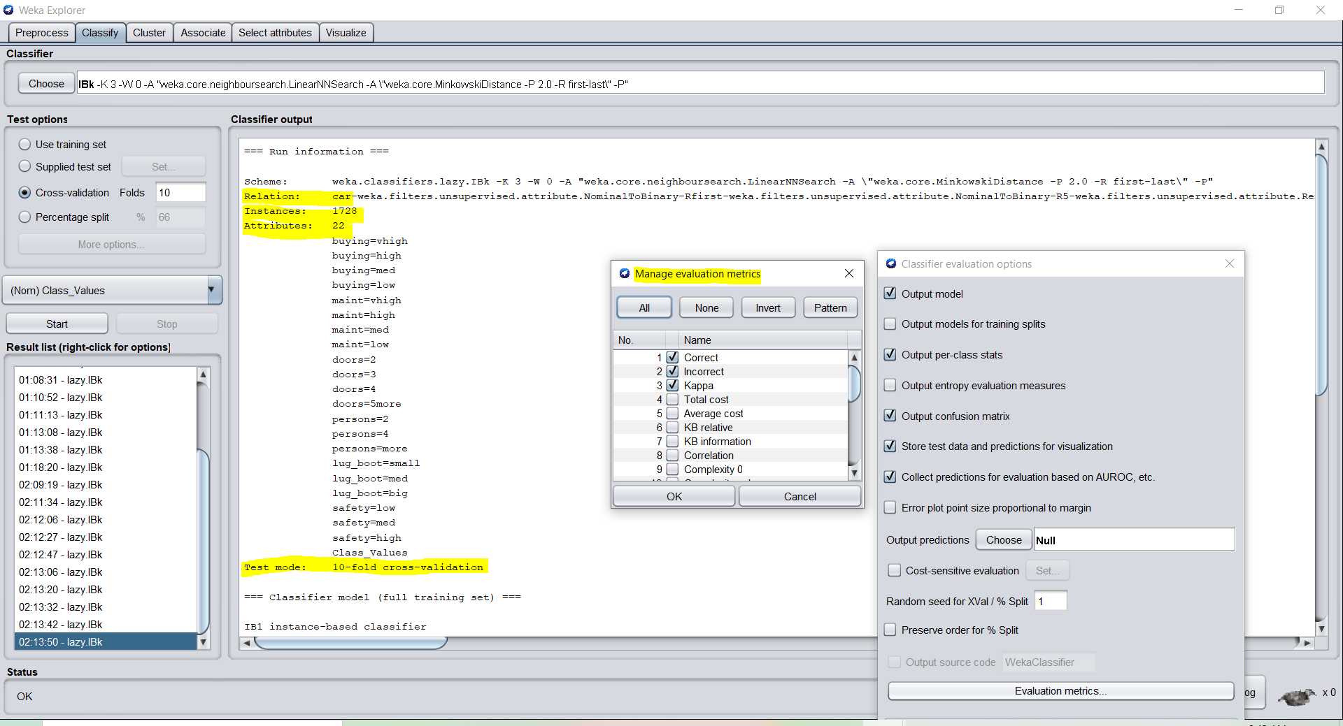

#### MINKOWSKI DISTANCE WITH KNN =3, CV Folds = 10, DATASET = “CAR EVALUATION”

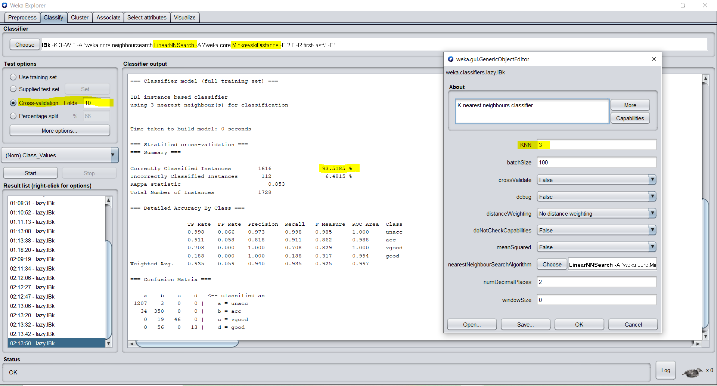

#### EUCLIDEAN DISTANCE WITH KNN =13 (Accuracy drops), CV Folds = 10, DATASET = “CAR EVALUATION”

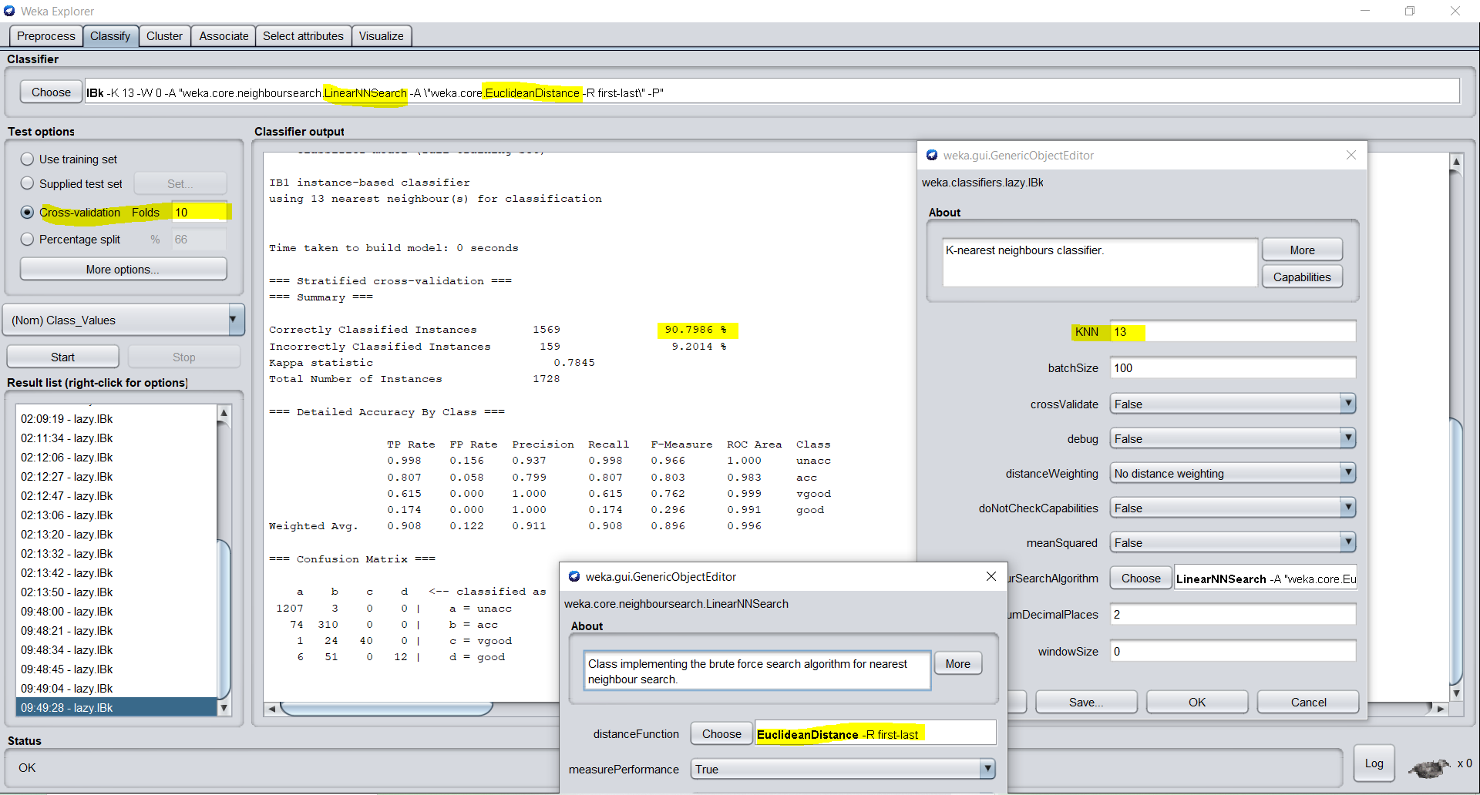

#### Manhattan Distance with K =3 and CV =10 (Good Accuracy), CV Folds = 10, DATASET = “CAR EVALUATION”

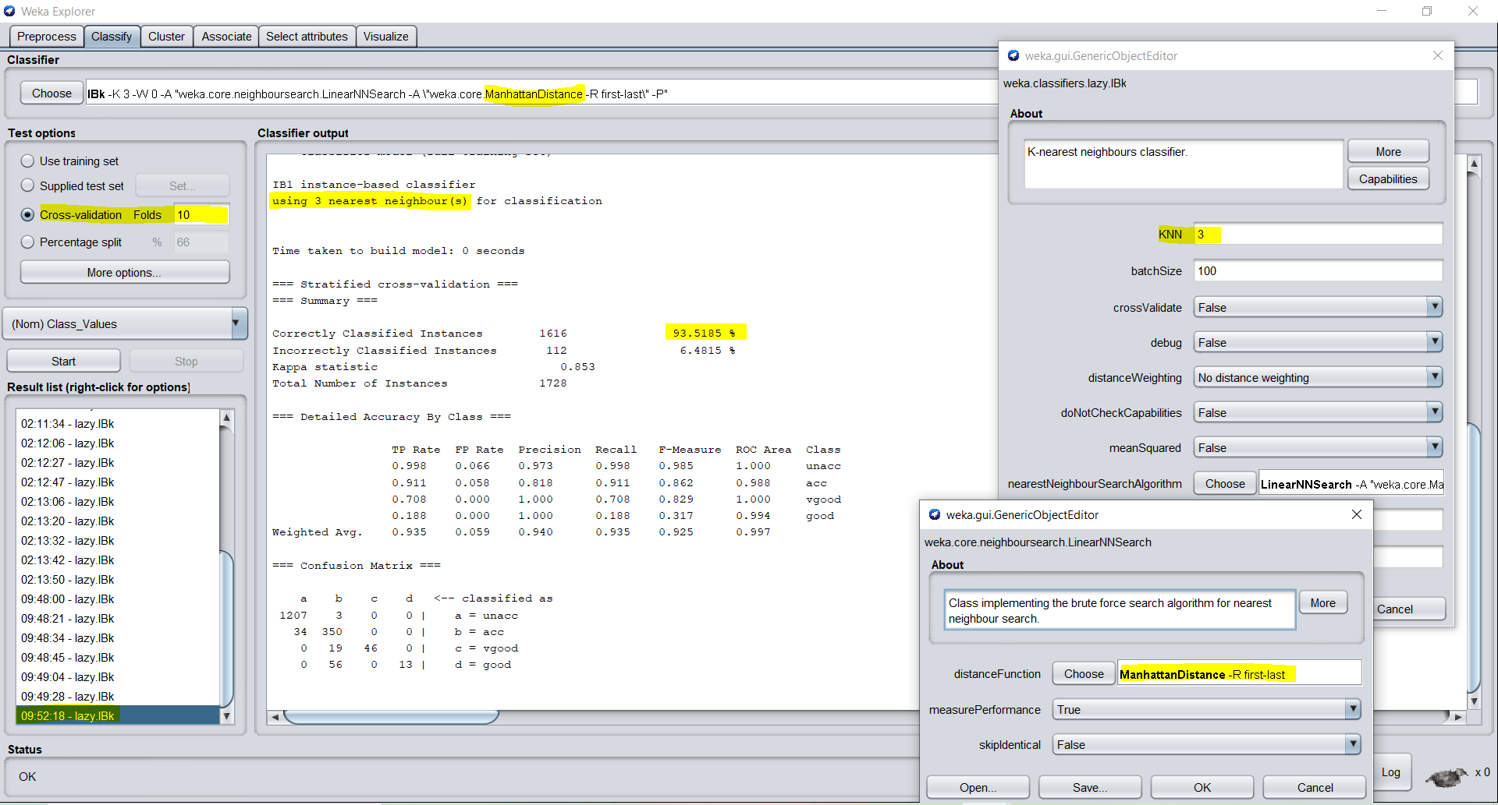

#### Chebyshev Distance with KNN=7, CV =15 (Worst Accuracy), DATASET = “CAR EVALUATION”

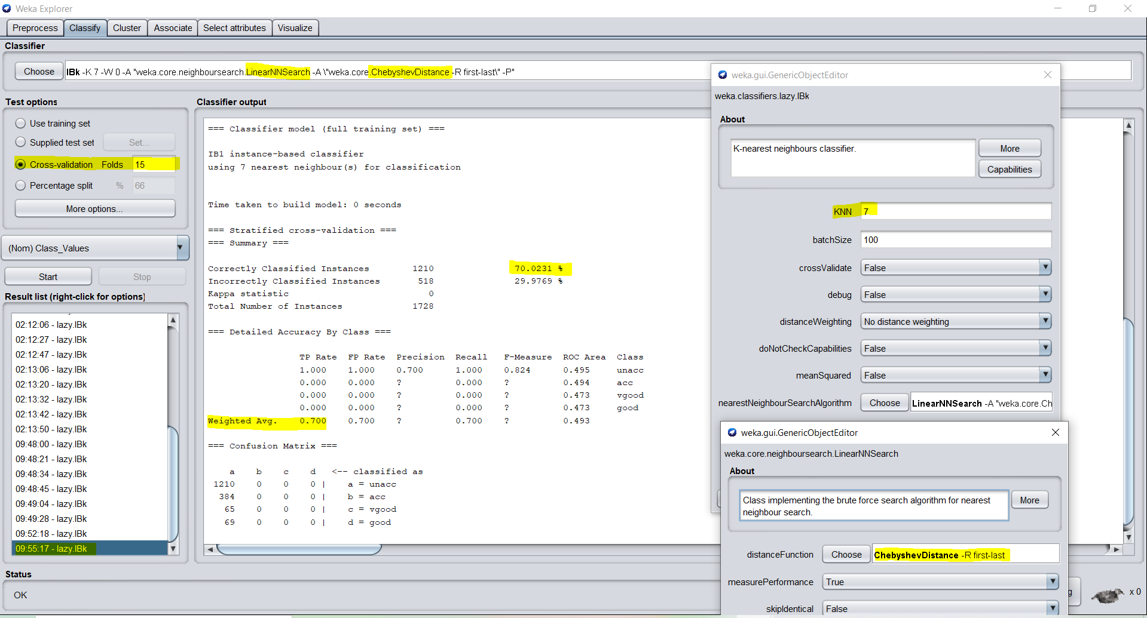

#### Training-Test Split: 70-30, KNN=5, Distance = Euclidean, DATASET = “CAR EVALUATION”

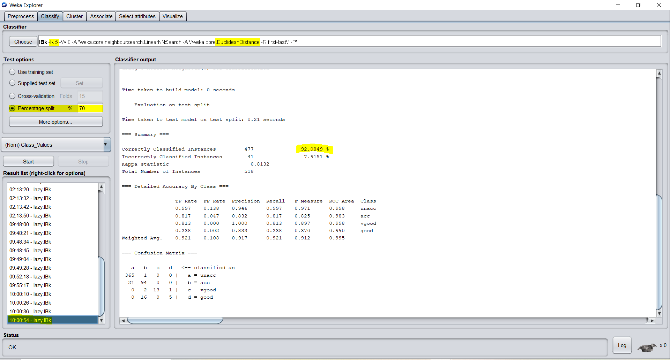

#### Training-Test Split: 80-20, KNN=5, Distance = Euclidean, DATASET = “CAR EVALUATION”

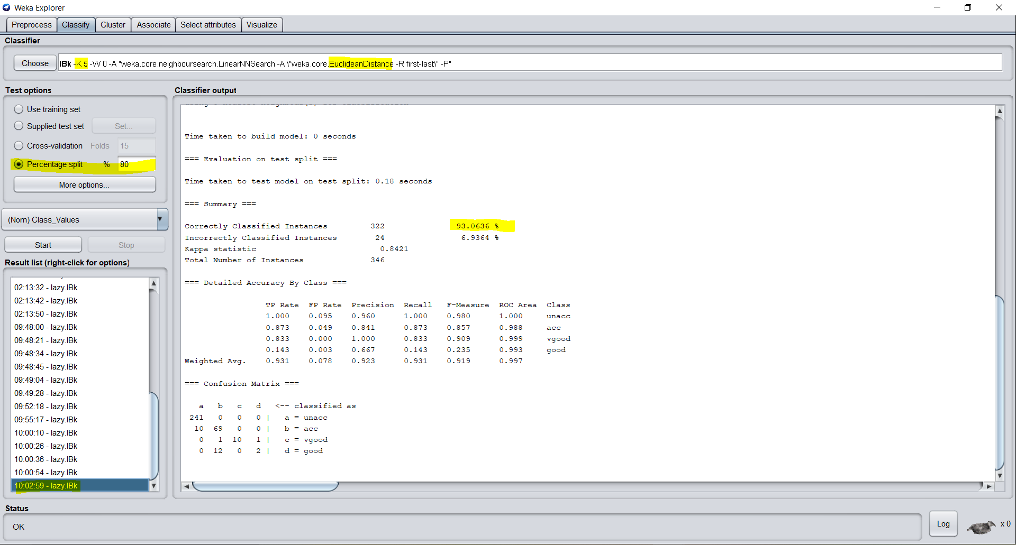

#### Training-Test Split: 65-35, KNN=3, Distance = Manhattan, DATASET = “CAR EVALUATION”

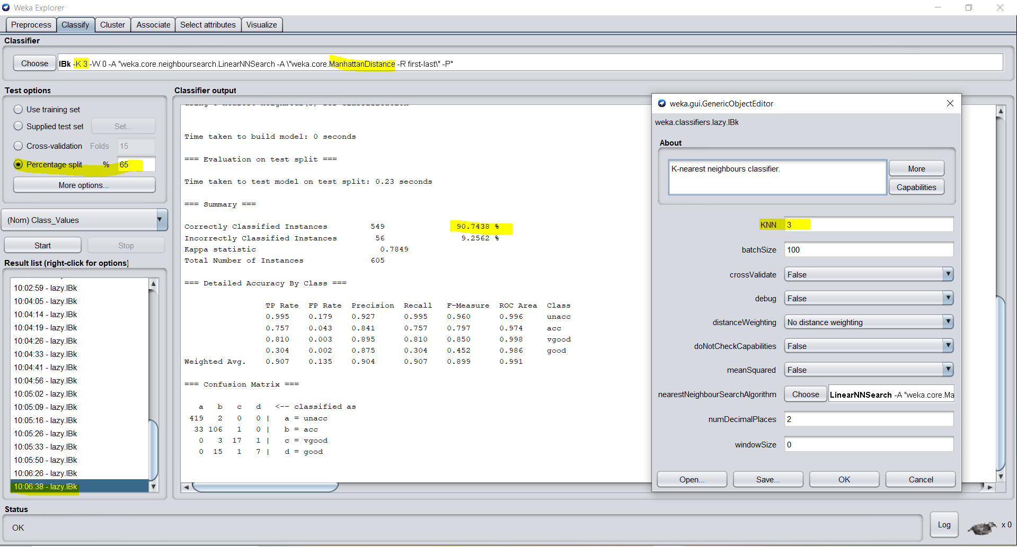

BEST ACCURACY ACHIEVED FOR CAR EVALUATION DATASET USING WEKA - **93.5185%**

BREAST CANCER DATASET

PRIOR TO PREPROCESSING - BREAST CANCER DATASET

LOADED THE BREAST CANCER DATASET IN WEKA

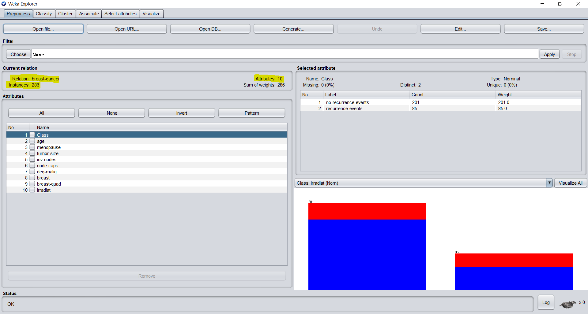

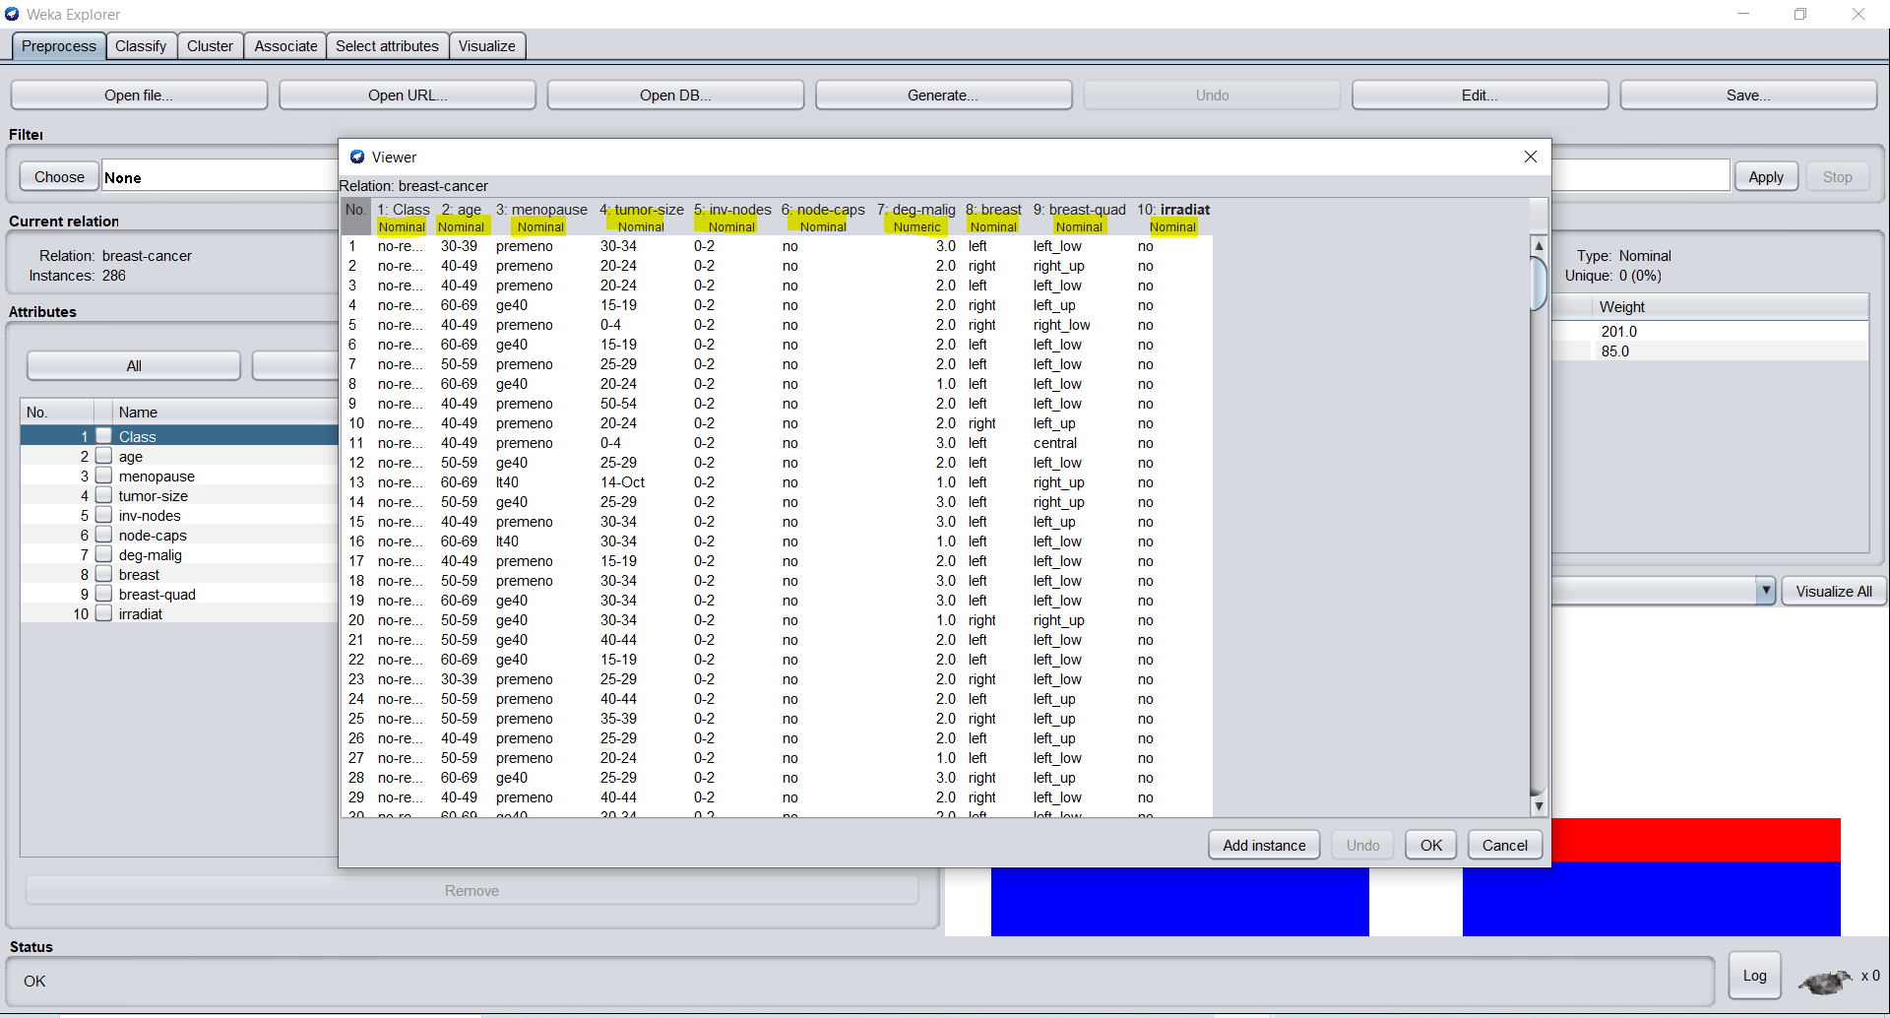

PREPROCESSING STEPS:

Applied filter “ReplaceMissingWithUserConstant” to replace missing value with the mode

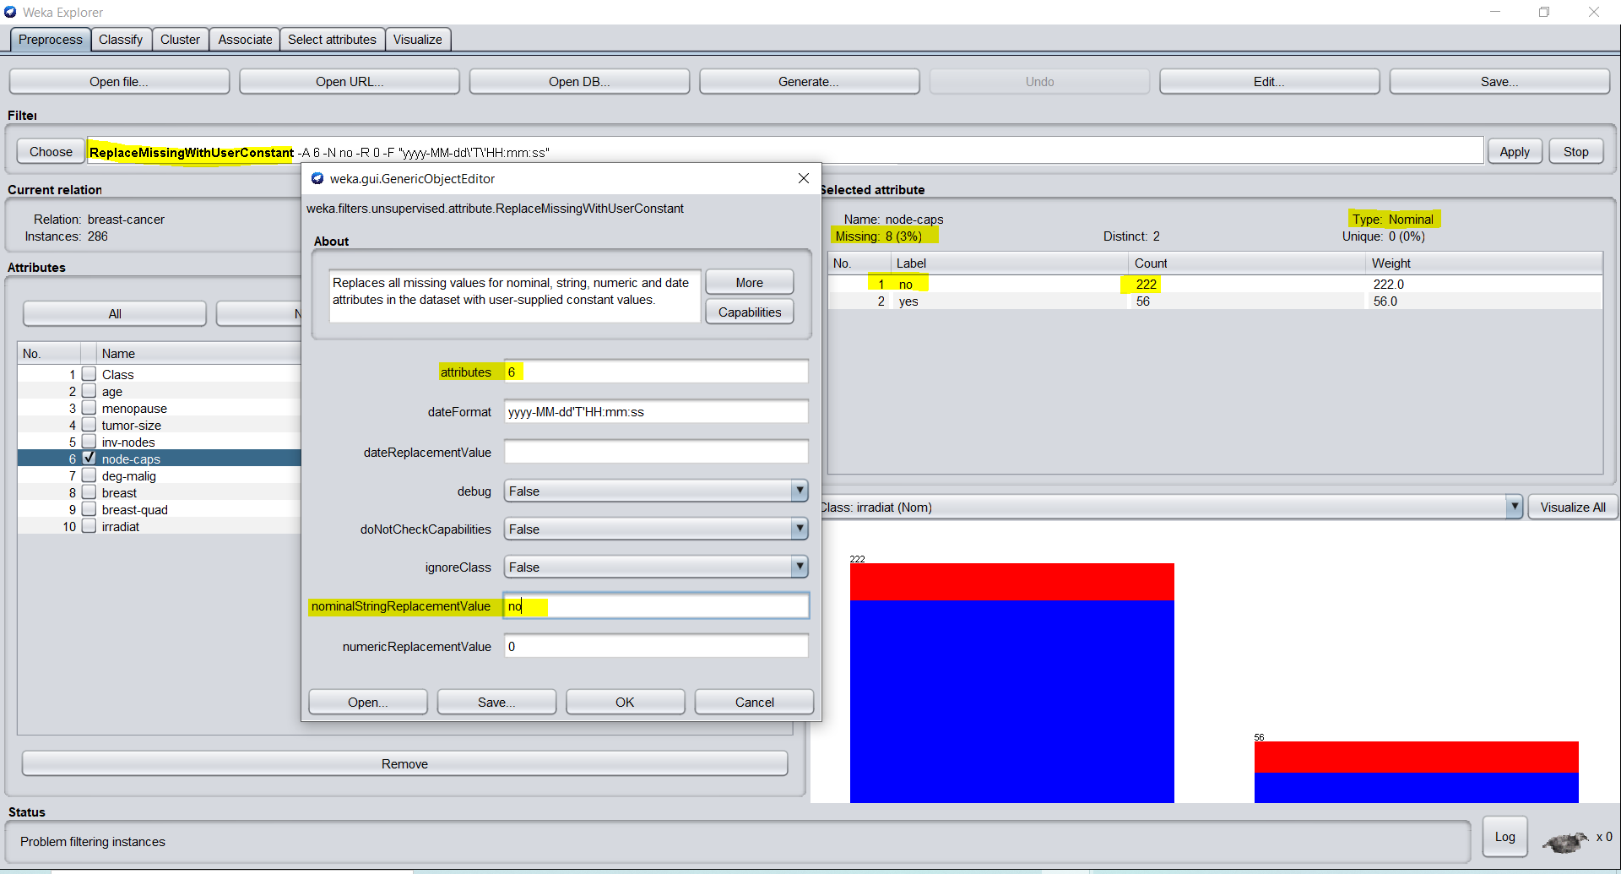

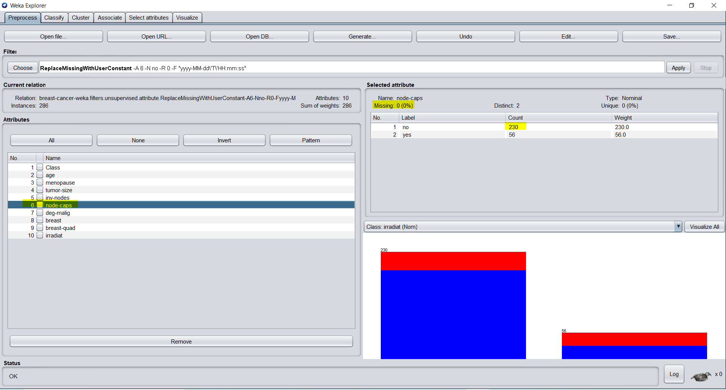

Used the mode value = ‘left_low’ to replace missing value (Mode Value)

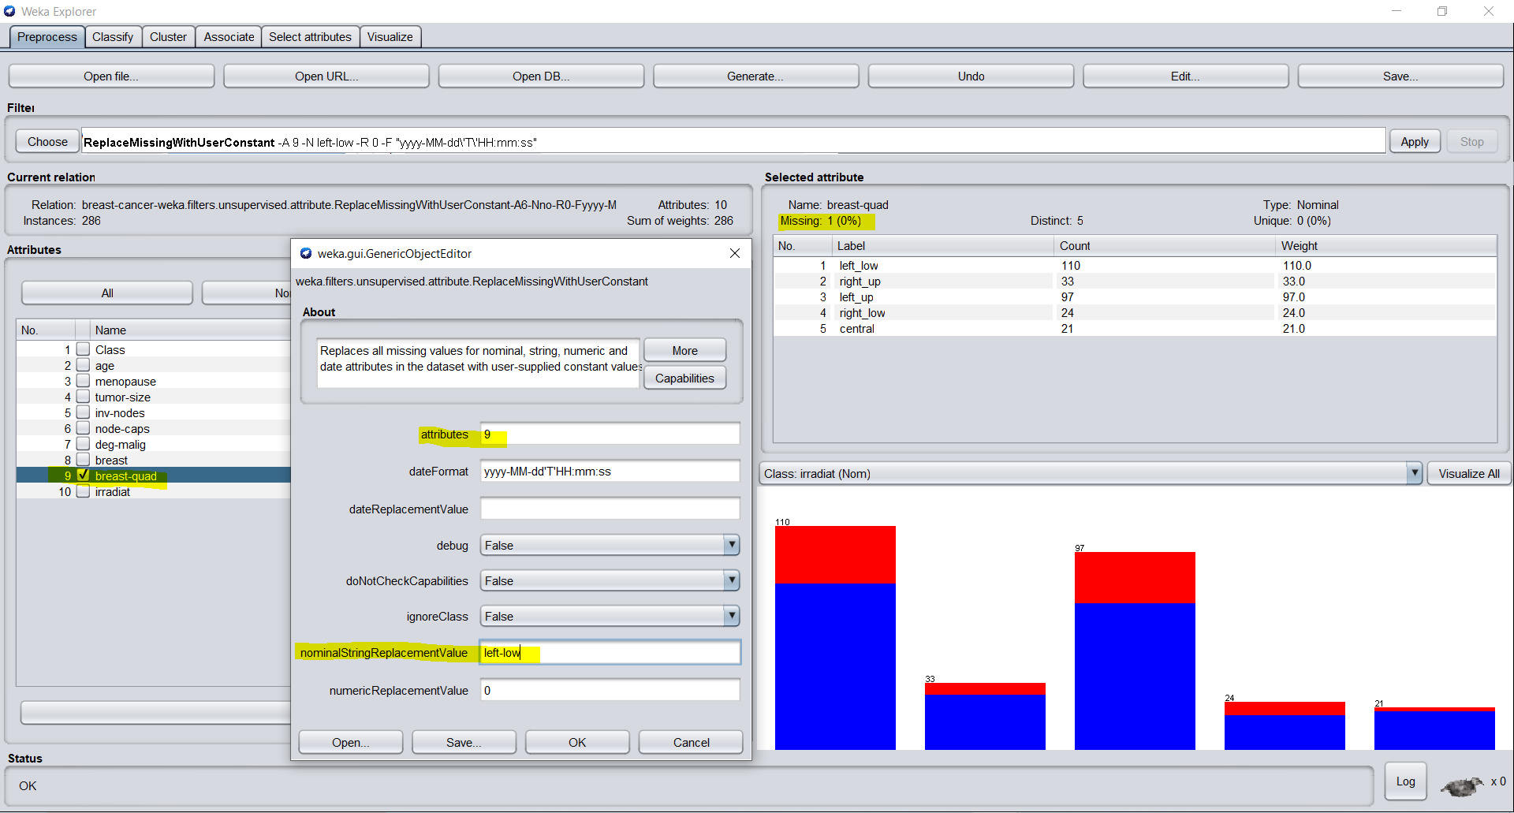

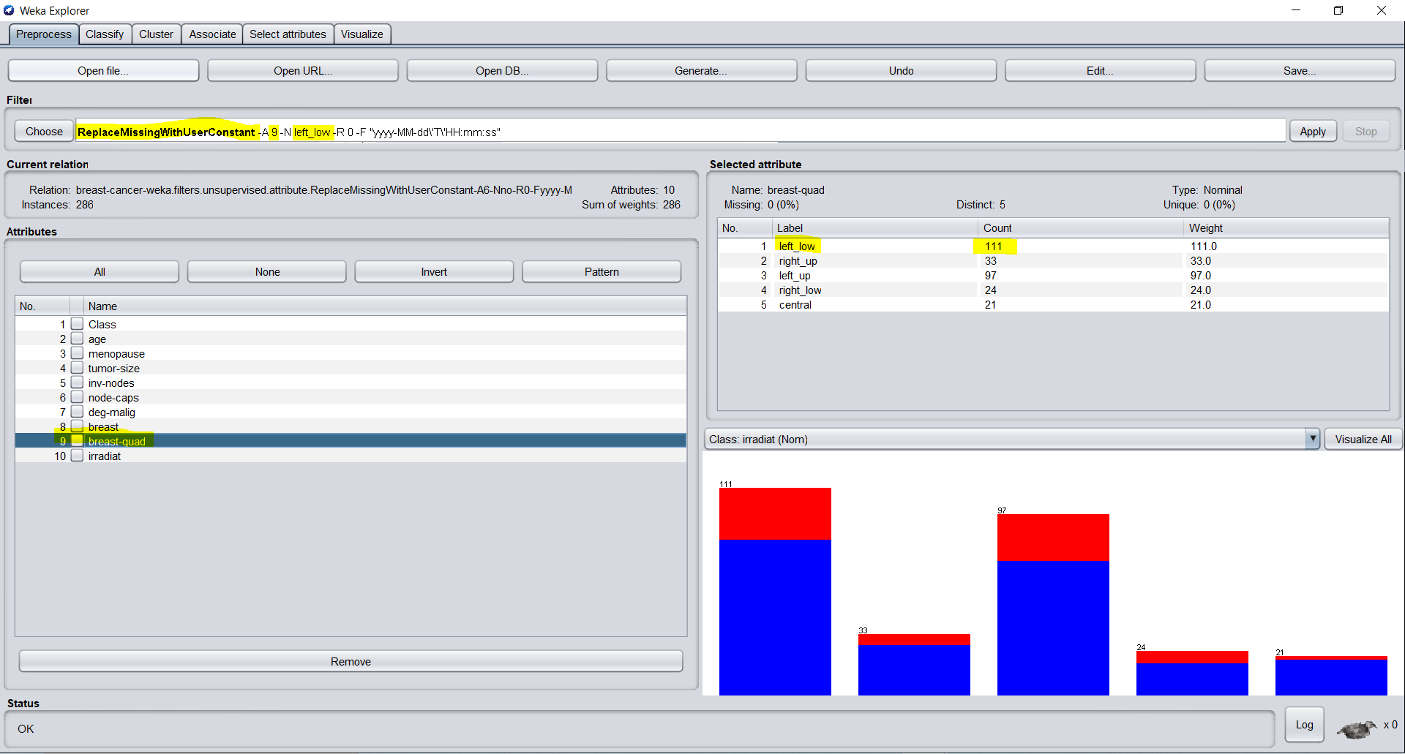

“NominaltoBinary” filter to all nominal columns – to convert to binary values

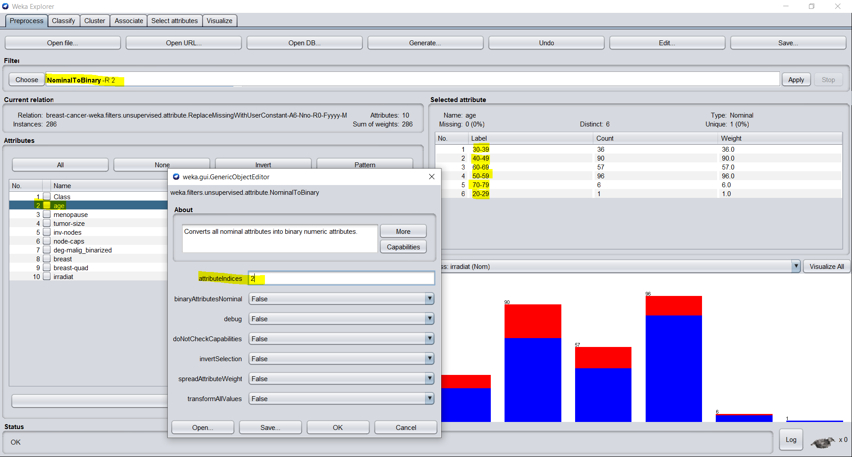

Normalize – scaleD the data values in the range of 0-1

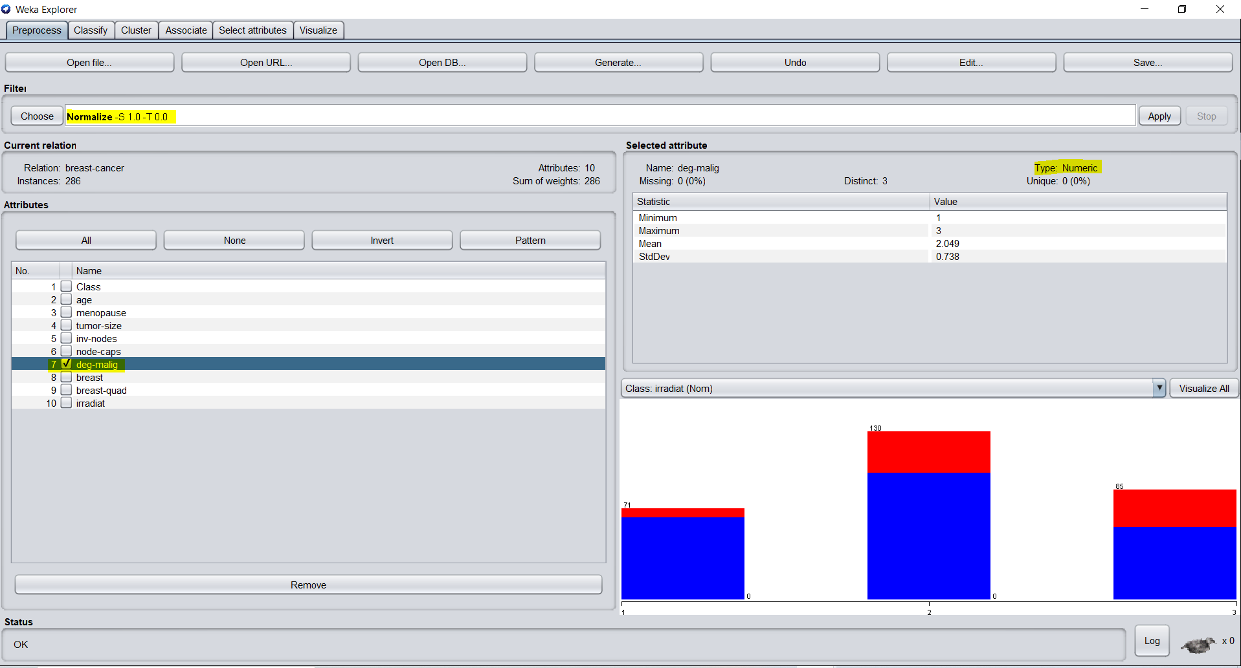

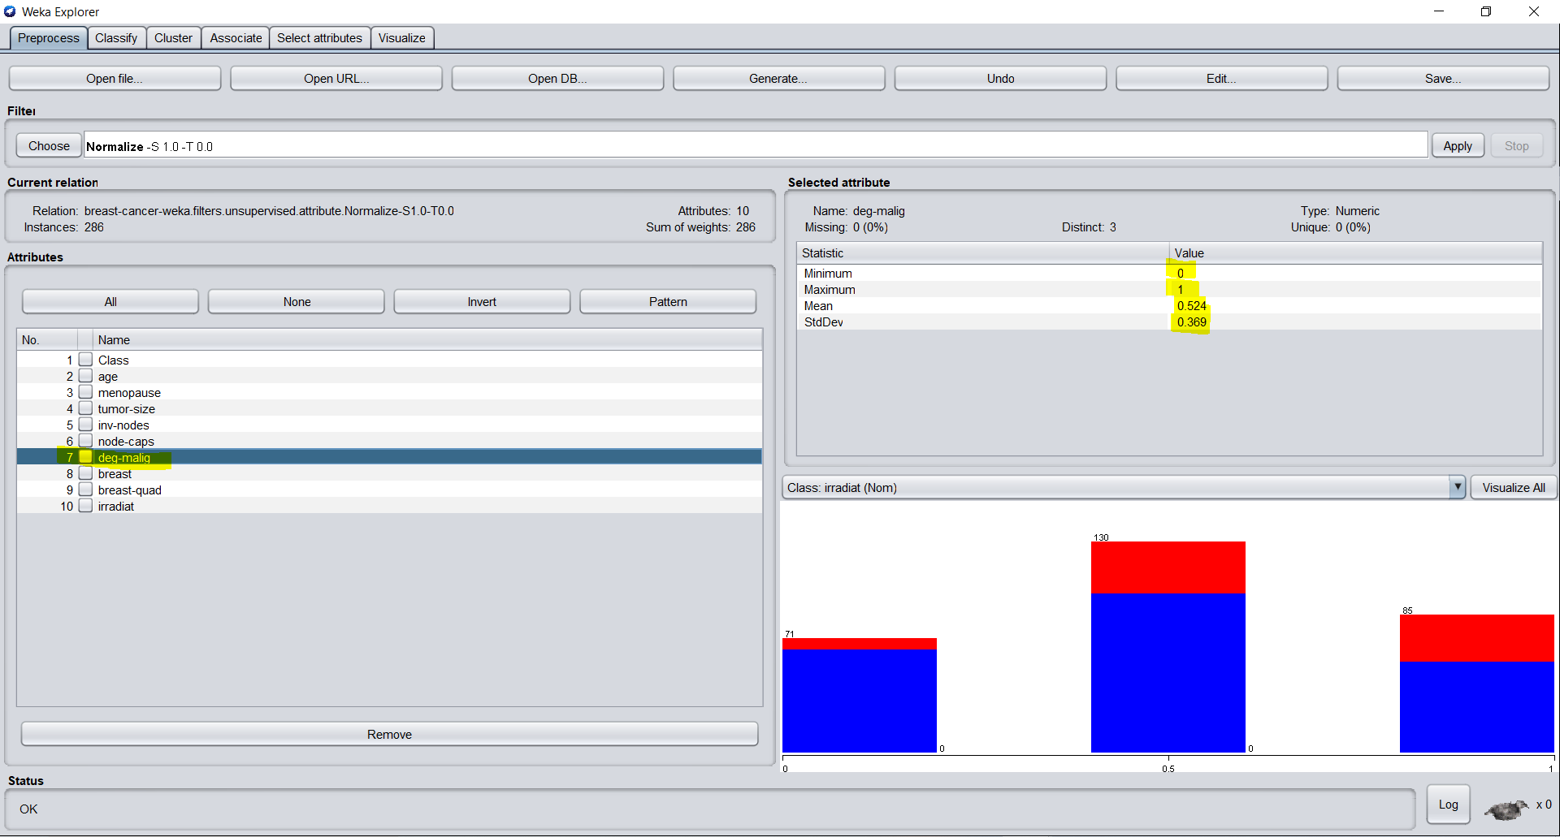

After Preprocessing

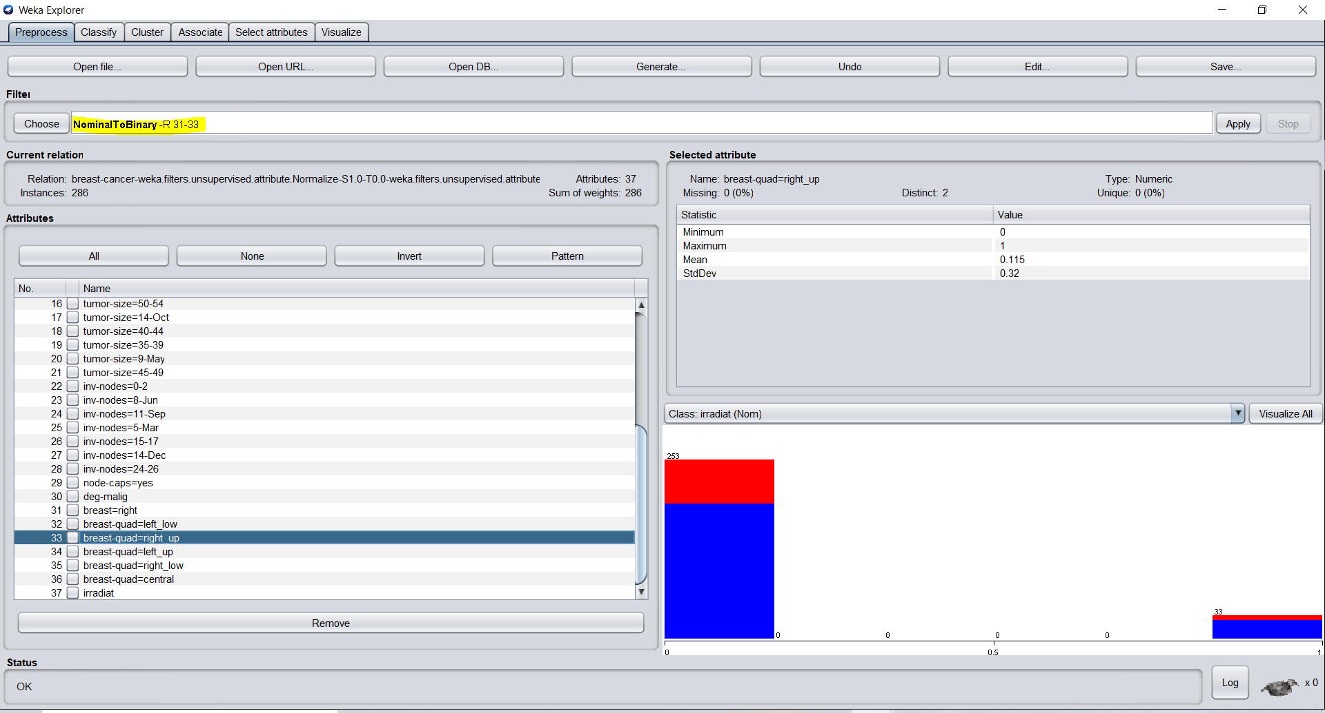

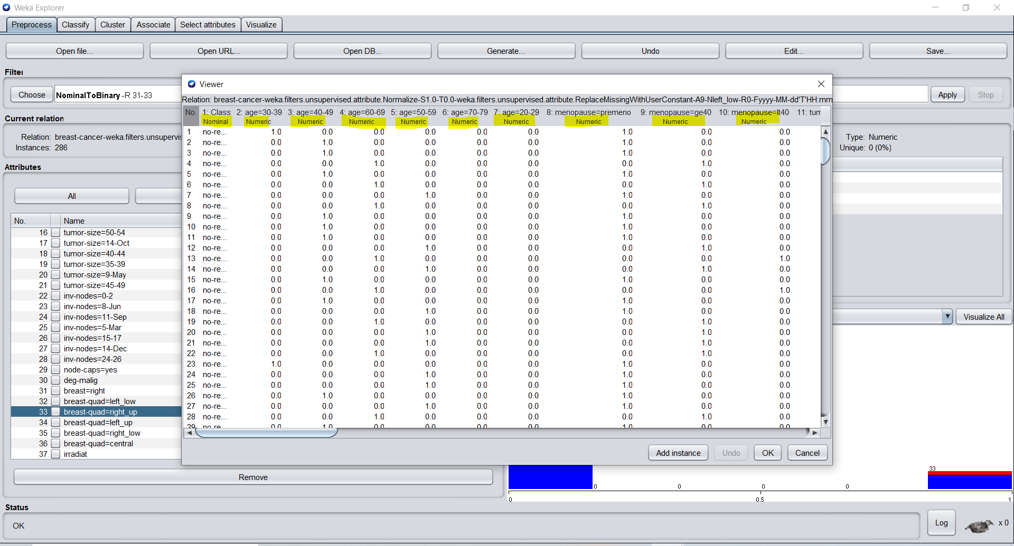

K=3, Distance=Euclidean, CV Folds =10, DATASET = “BREAST CANCER”

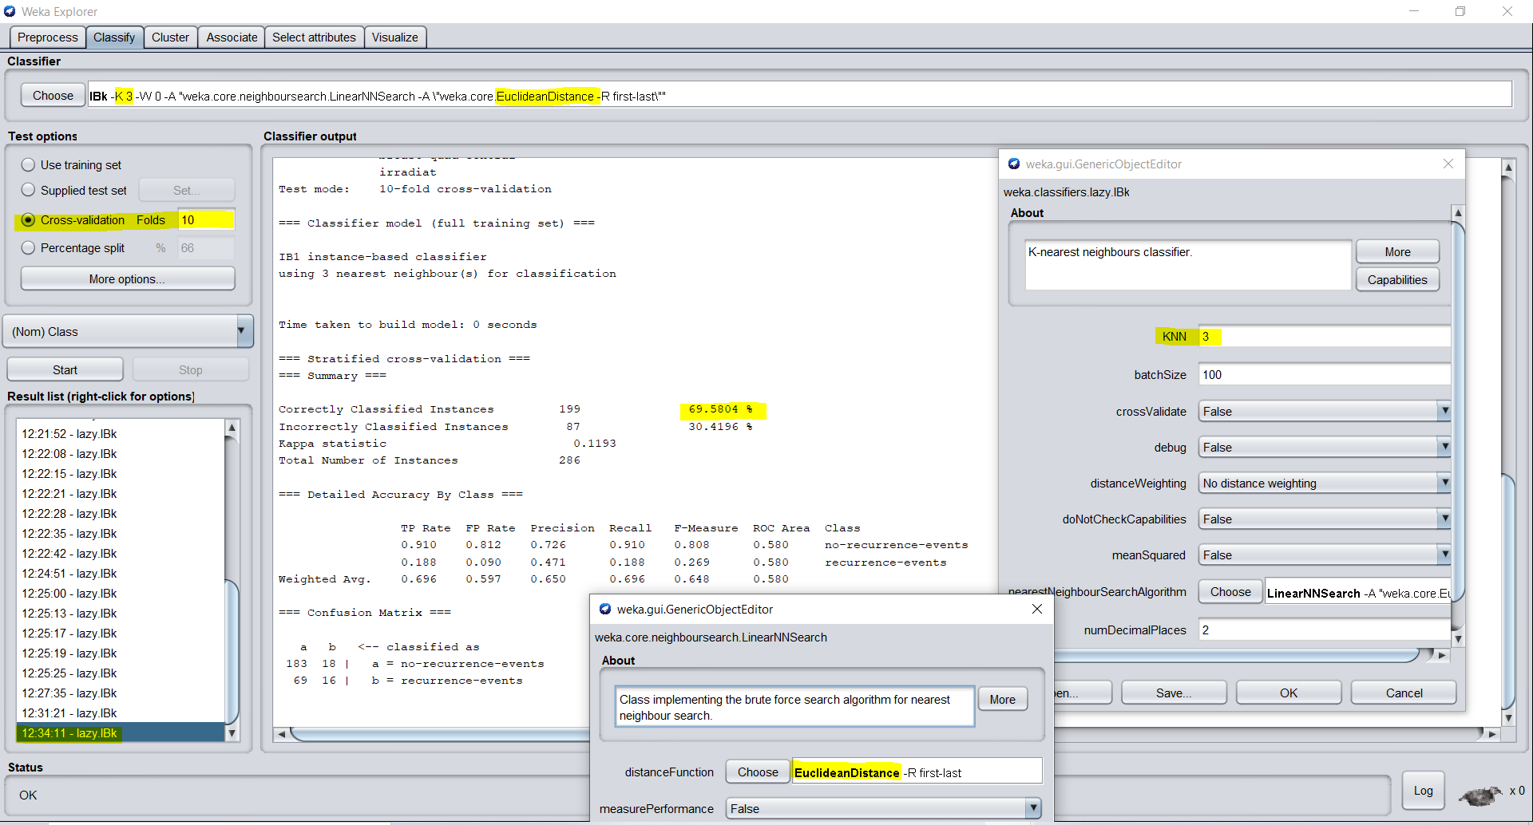

K=17, Distance=Manhattan, CV Folds =10, DATASET = “BREAST CANCER”

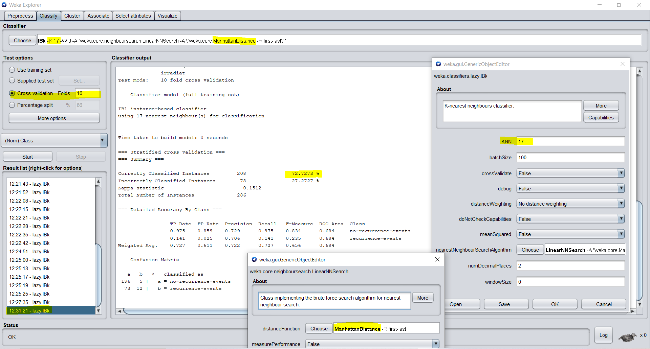

K=7, Distance=Minkowski, CV Folds =10, DATASET = “BREAST CANCER”

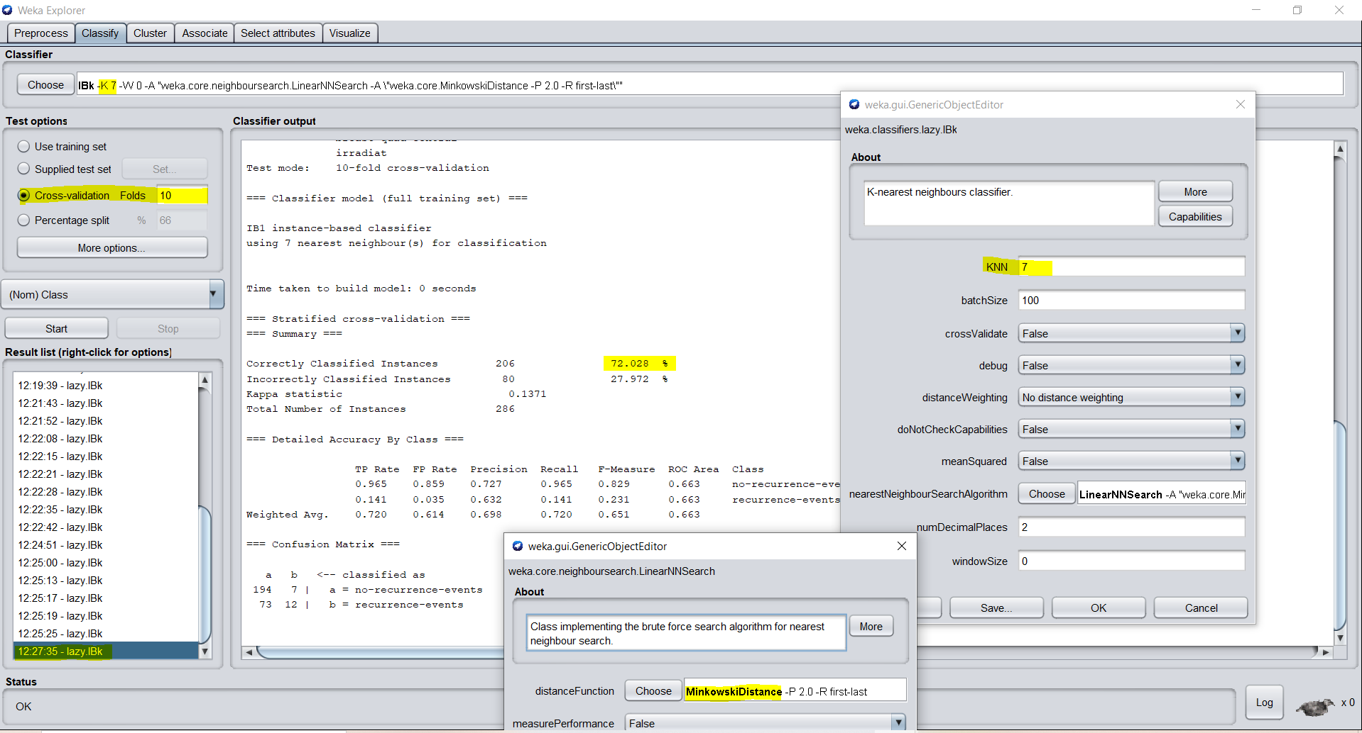

K=3, Distance=Chebyshev, CV Folds =10, DATASET = “BREAST CANCER”

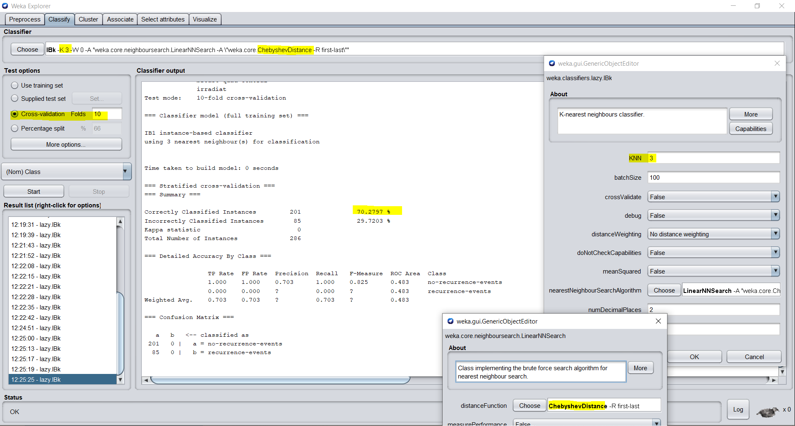

K=17, Distance=Euclidean, Train-Test Split: 70-30, DATASET = “BREAST CANCER”

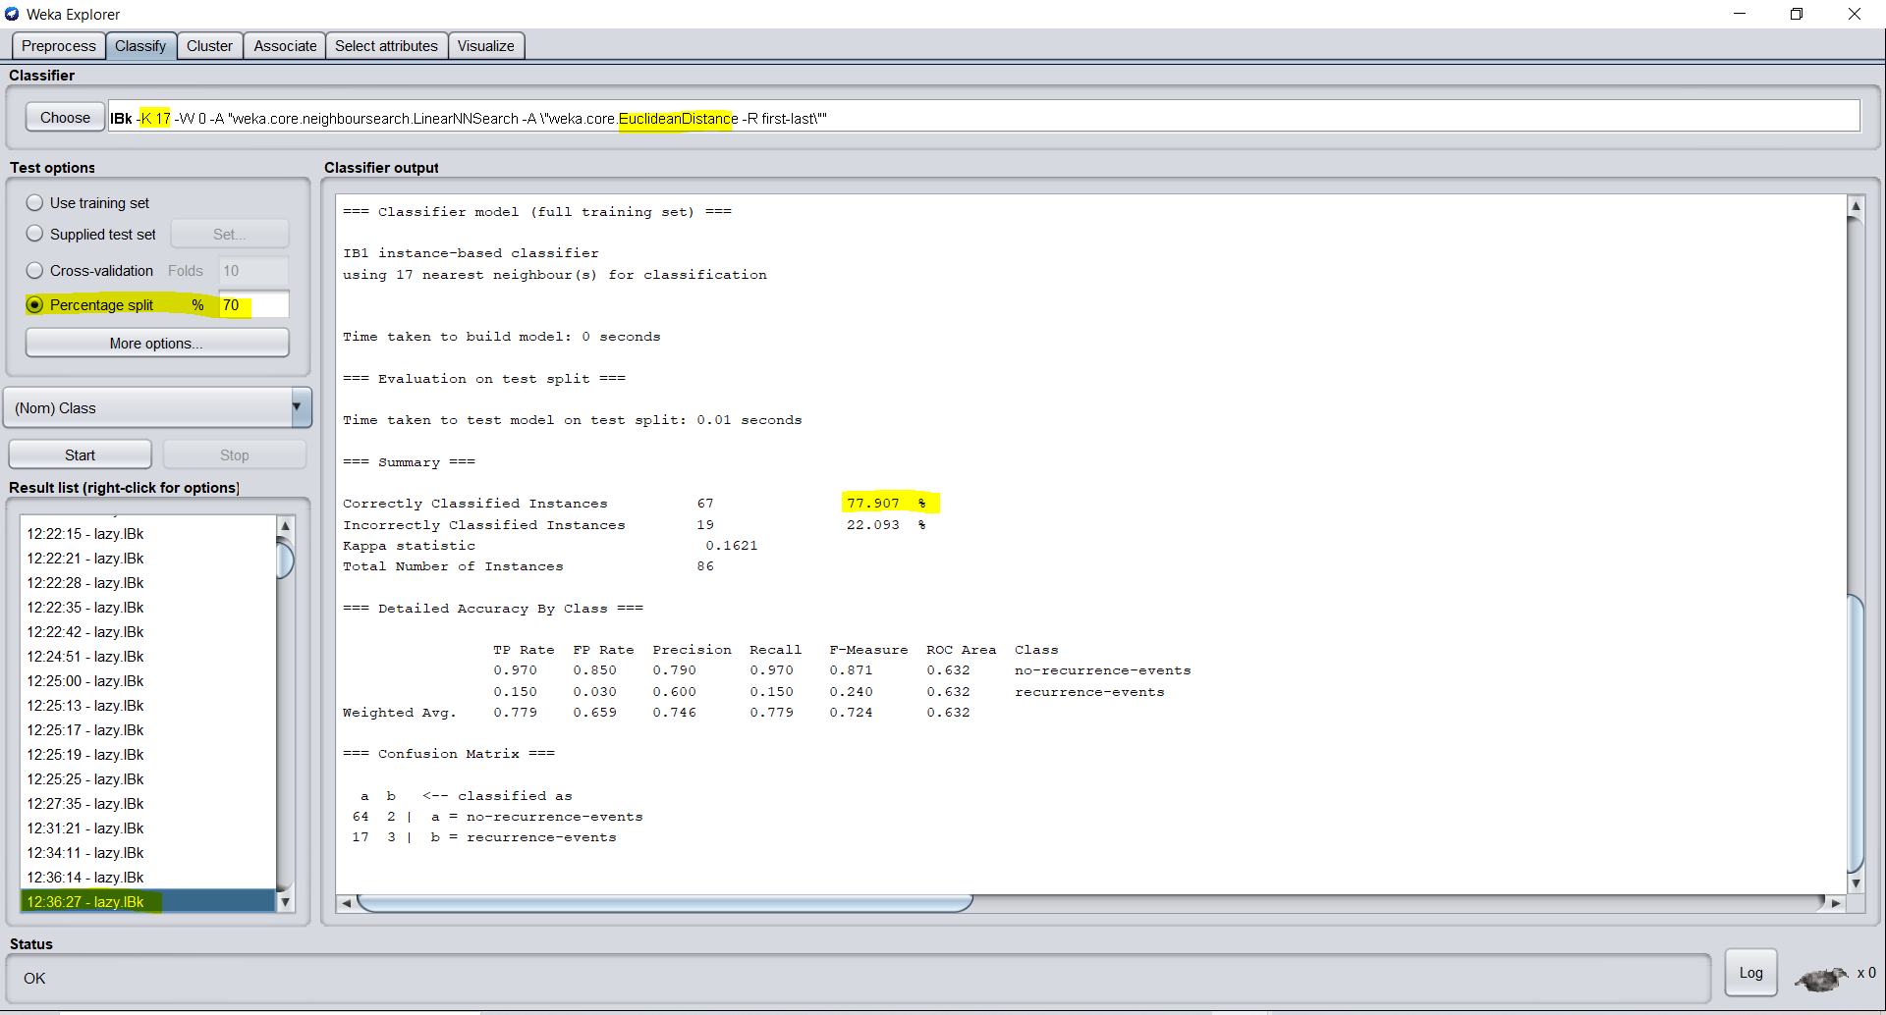

K=17, Distance=Euclidean, Train-Test Split: 69-31, DATASET = “BREAST CANCER”

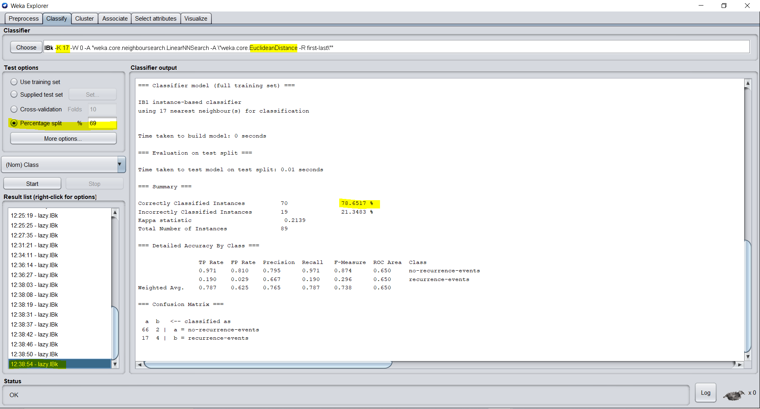

K=3, Distance=Manhattan, Train-Test Split: 80-20, DATASET = “BREAST CANCER”

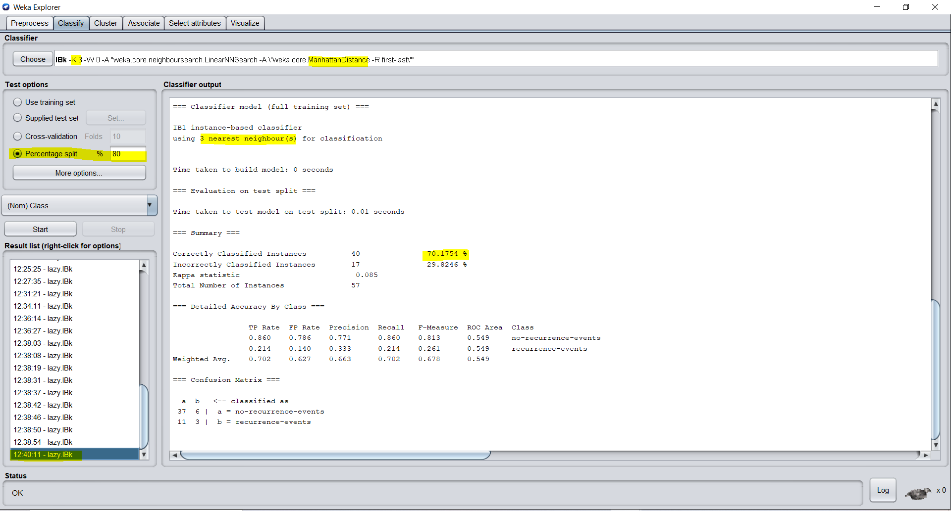

BEST ACCURACY ACHIEVED FOR BREAST CANCER DATASET USING WEKA - **78.6517%**

HAYES-ROTH DATASET

PRIOR TO PREPROCESSING

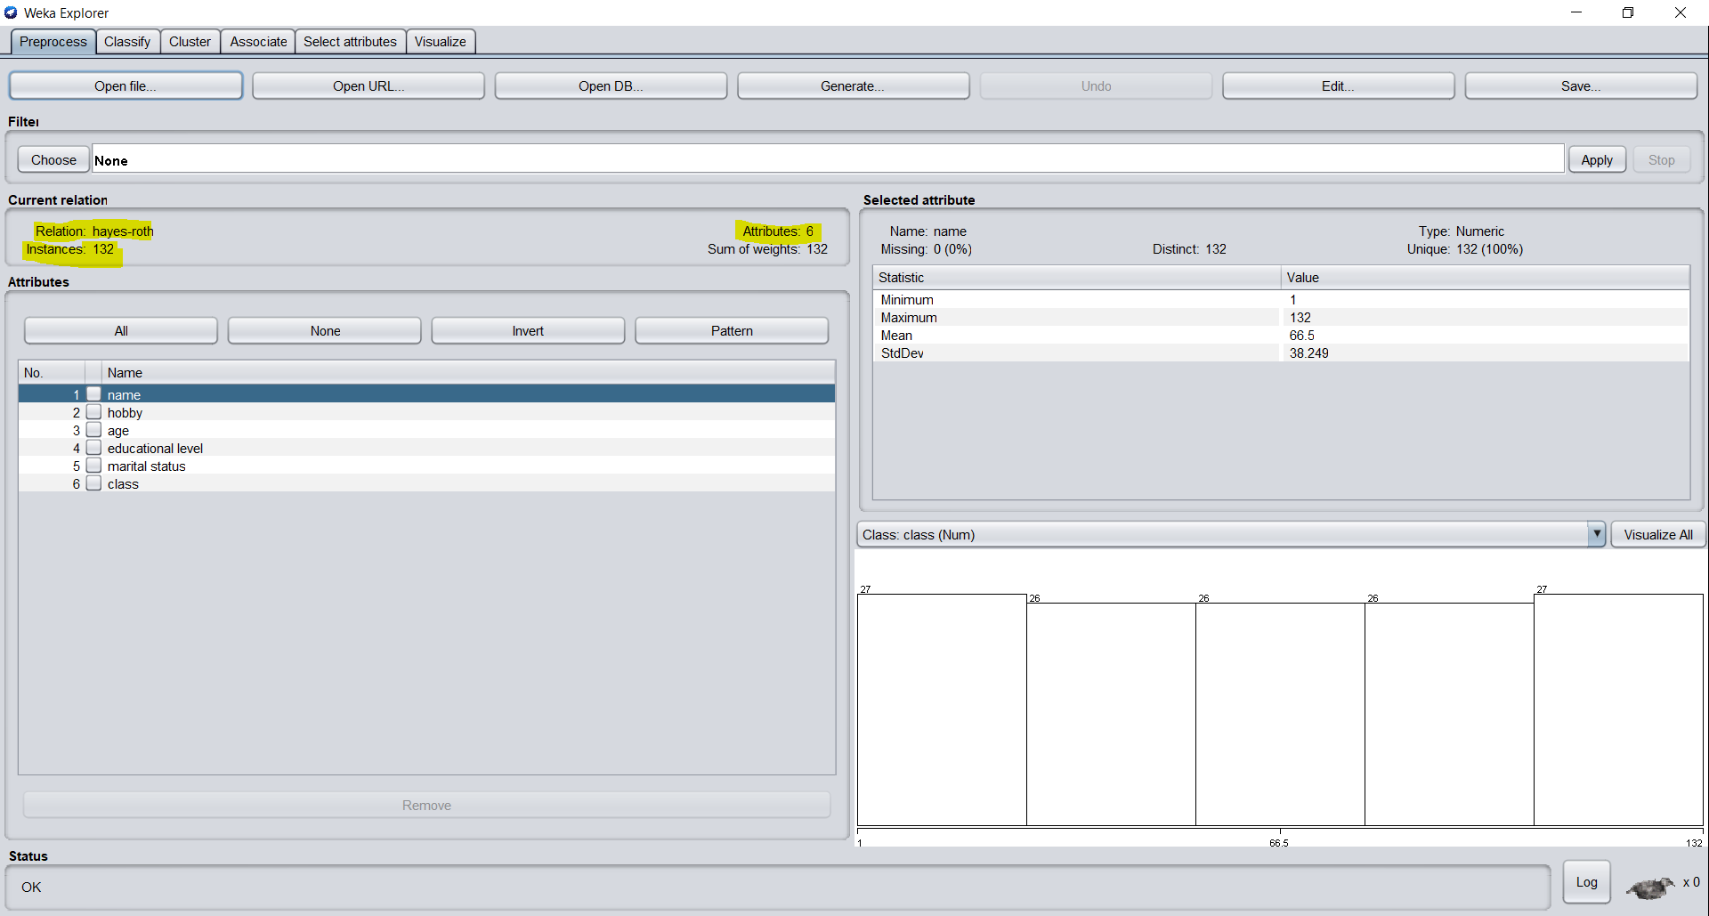

Applied “NumerictoNominal” filter for IBK Classifier to identify this as a classification problem

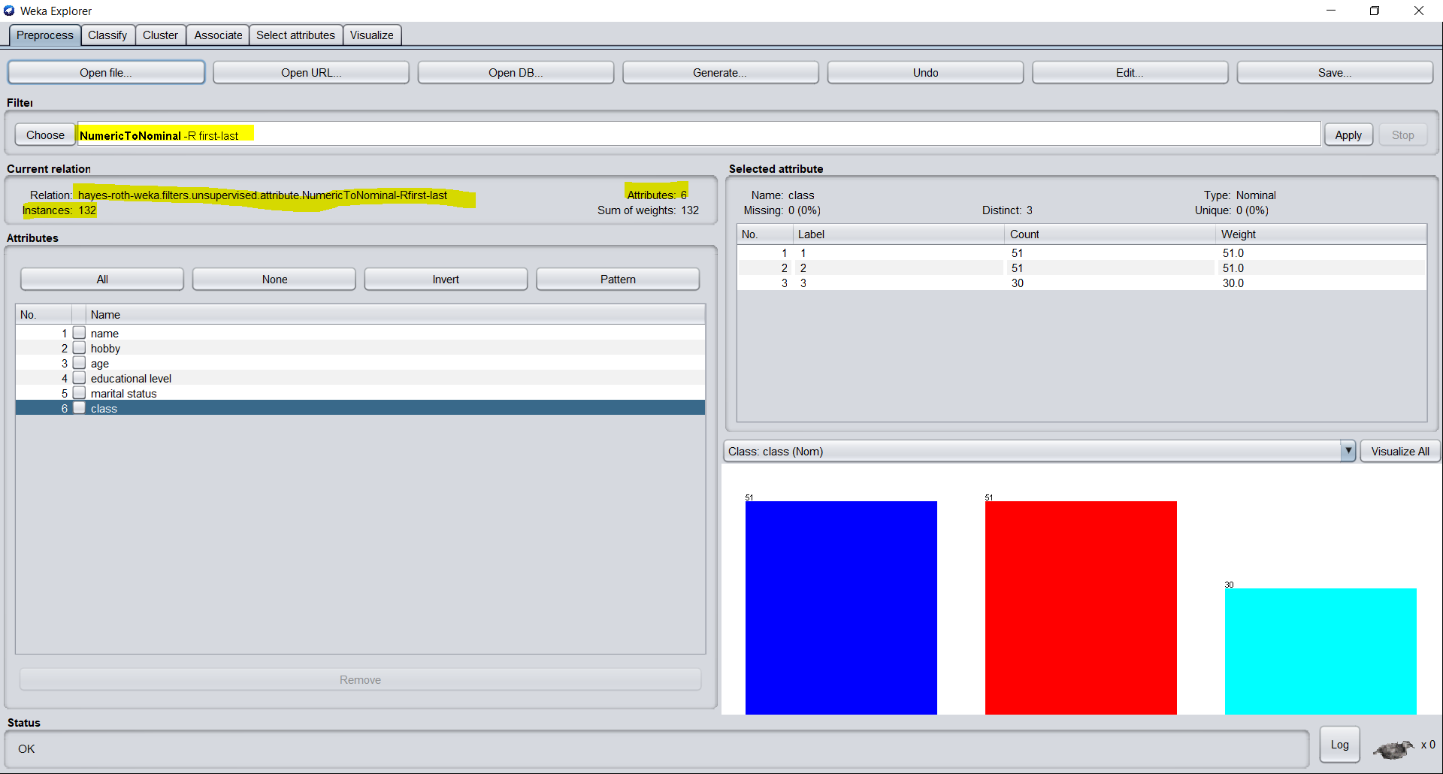

K=3, Distance= Euclidean, CV Folds =10, DATASET = “HAYES-ROTH”

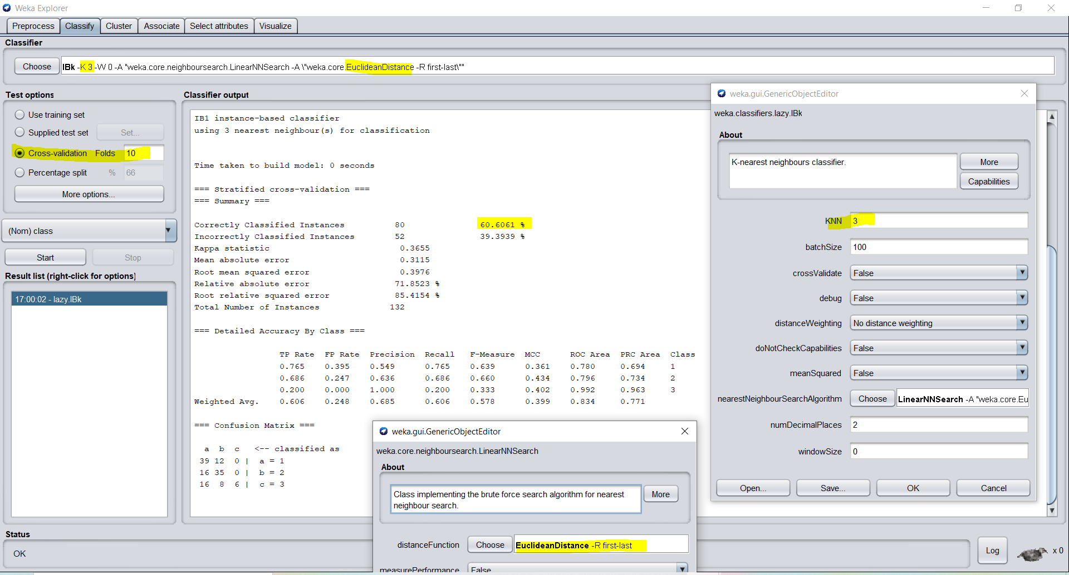

K=13, Distance = Manhattan, CV Folds =10, DATASET = “HAYES-ROTH”

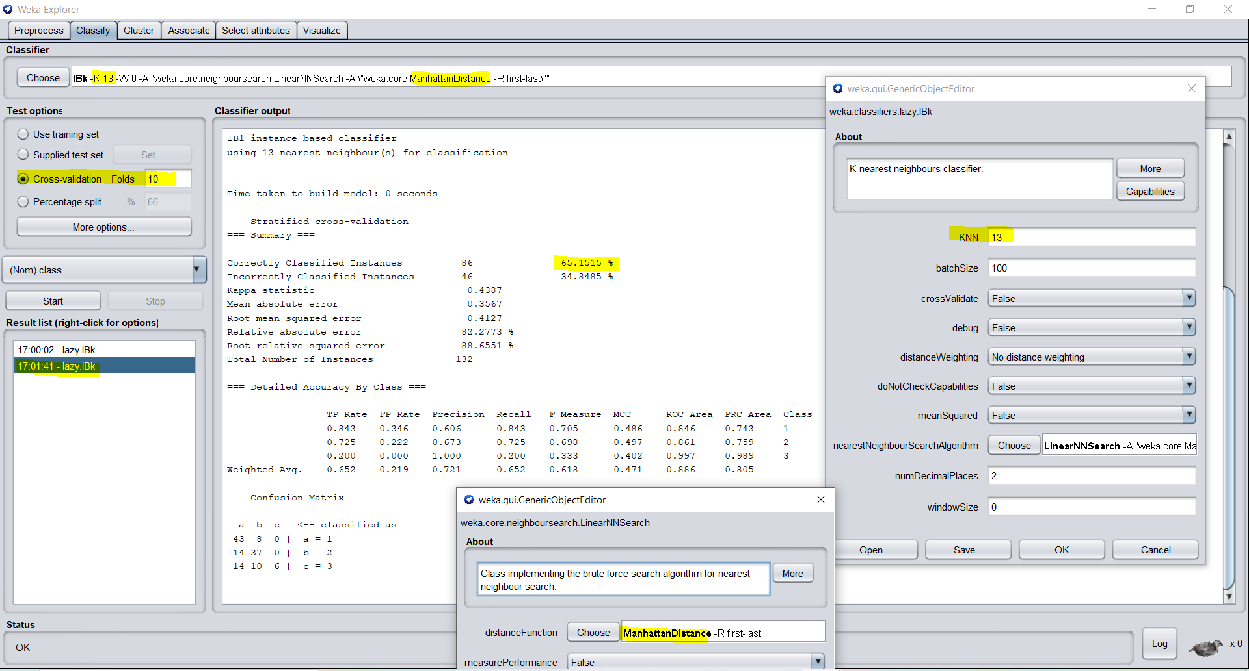

K=7, Distance= Minkowski, CV Folds =10, DATASET = “HAYES-ROTH”

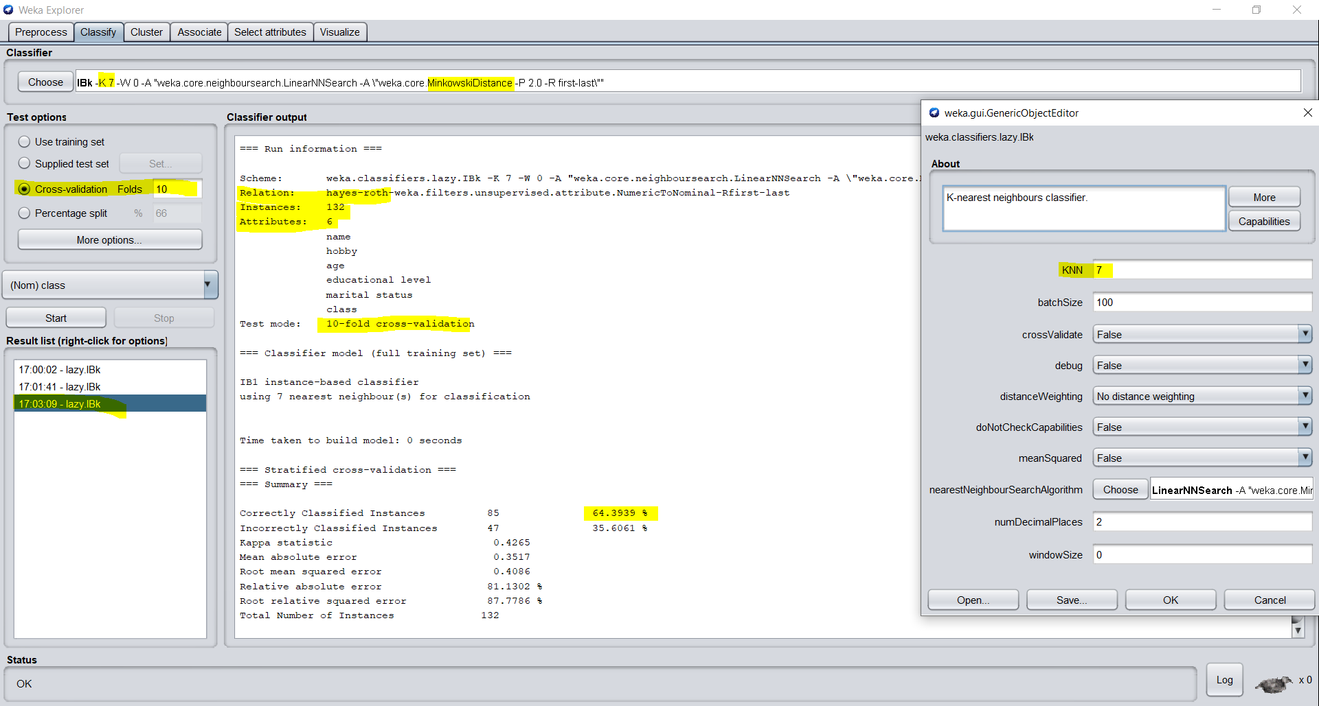

K=5, Distance = Chebyshev, CV Folds =10, DATASET = “HAYES-ROTH”

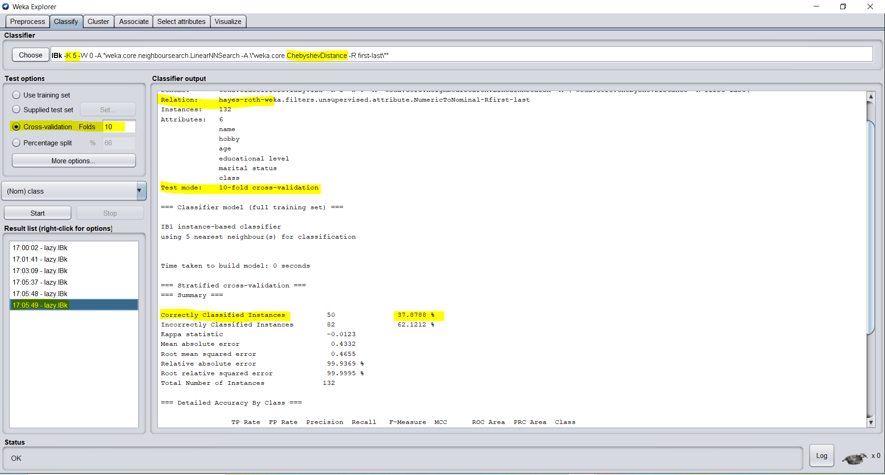

K=5, Distance = Euclidean, Train-Test Split = 70-30, DATASET = “HAYES-ROTH”

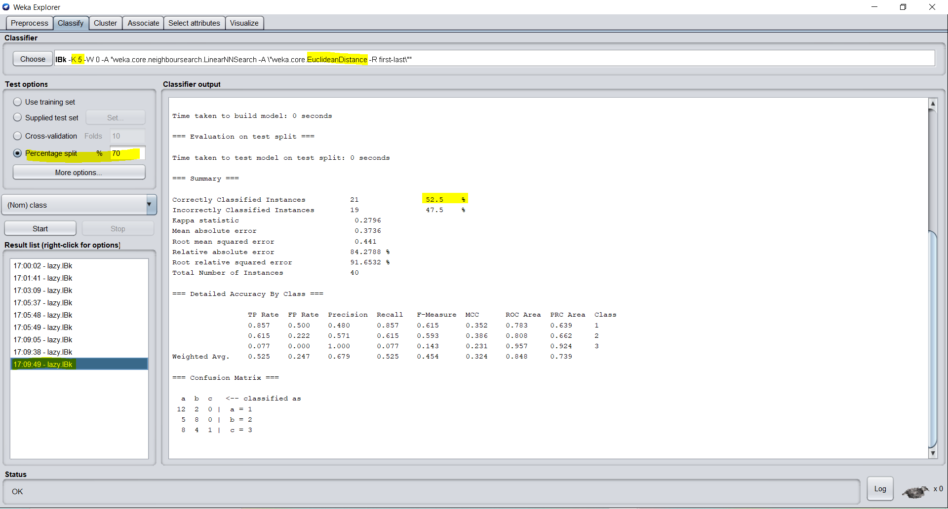

K=13, Distance= Euclidean, Train-Test Split = 80-20, DATASET = “HAYES-ROTH”

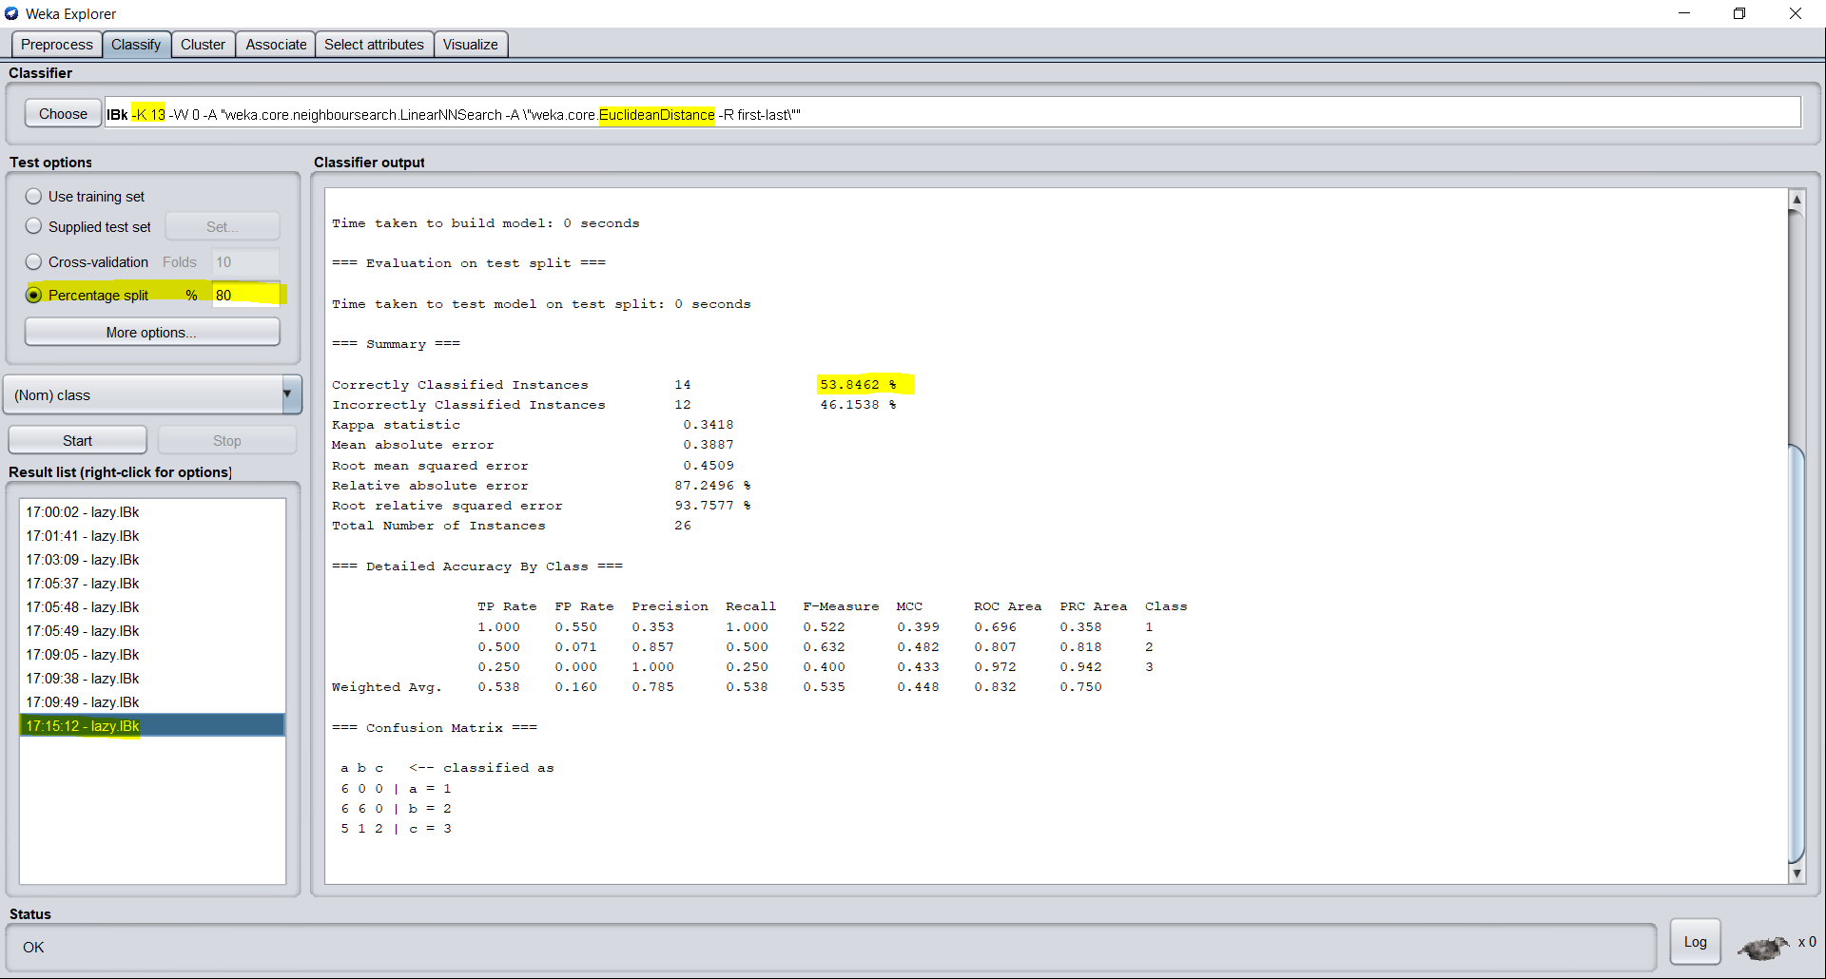

K=7, Distance= Manhattan, Train-Test Split = 65-35, DATASET = “HAYES-ROTH”

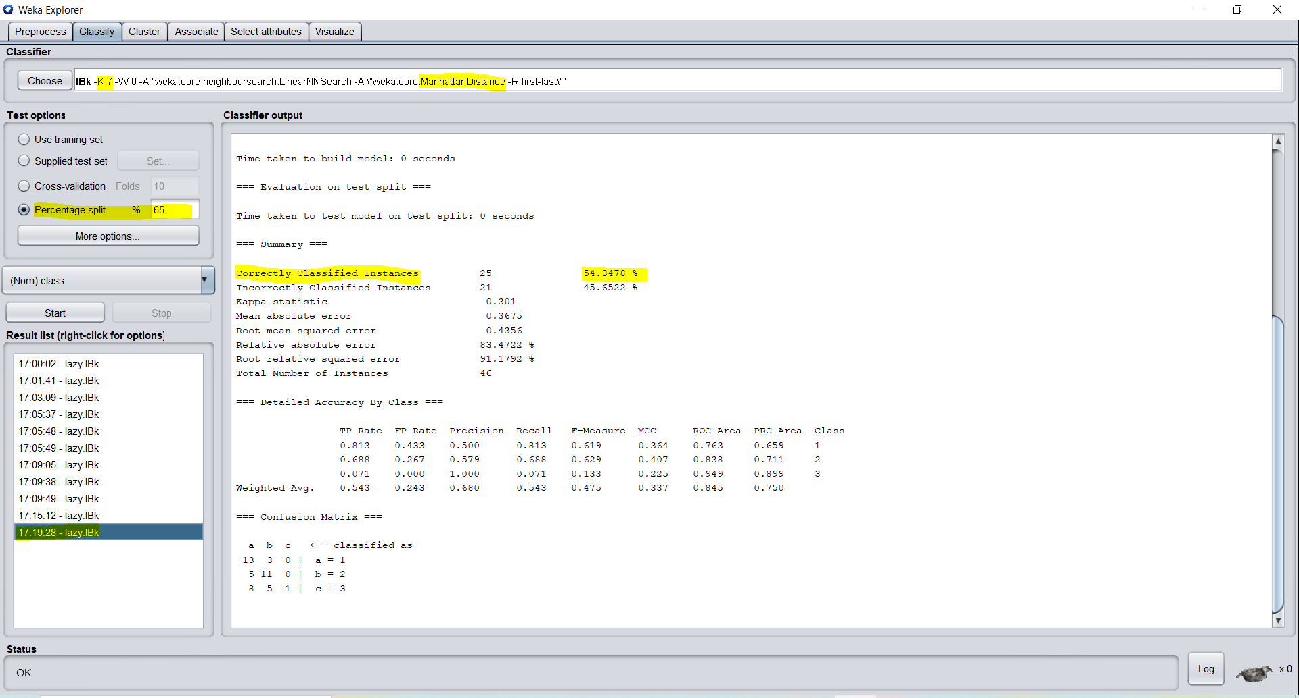

BEST ACCURACY ACHIEVED FOR BREAST CANCER DATASET USING WEKA – **65.1515%**

# 3. COMPARISON OF ACCURACY RESULTS

|  |  |  |  |  |  |
| --- | --- | --- | --- | --- | --- |
| KNN IMPLEMENTATION OF ACCURACY RESULTS IN PYTHON | | | | | |
| DATASET | K | CV FOLDS | DISTANCE | PERCENTAGE SPLIT | MEAN ACCURACY |
| HAYES ROTH | 3 | 10 | Euclidean | None | 32.308% |
| HAYES ROTH | 5 | 10 | Hamming | None | 60.769% |
| HAYES ROTH | 11 | 10 | Manhattan | None | 38.462% |
| HAYES ROTH | 13 | 10 | Jaccard Similarity | None | 0.769% |
| CAR EVALUATION | 3 | 10 | Euclidean | None | 88.488% |
| CAR EVALUATION | 5 | 10 | Hamming | None | 85.756% |
| CAR EVALUATION | 11 | 10 | Manhattan | None | 69.942% |
| CAR EVALUATION | 7 | 10 | Jaccard Similarity | None | 52.558% |
| BREAST CANCER | 11 | 10 | Euclidean | None | 77.143% |
| BREAST CANCER | 13 | 10 | Hamming | None | 77.857% |
| BREAST CANCER | 11 | 10 | Manhattan | None | 70.000% |
| KNN IMPLEMENTATION OF ACCURACY RESULTS IN WEKA | | | | | |
| DATASET | K | CV FOLDS | DISTANCE | PERCENTAGE SPLIT | MEAN ACCURACY |
| HAYES ROTH | 13 | 10 | Manhattan | None | 65.1515% |
| HAYES ROTH | 7 | 10 | Minkowski | None | 64.3939% |
| HAYES ROTH | 5 | 10 | Chebyshev | None | 37.8788% |
| HAYES ROTH | 7 | None | Euclidean | 65-35 | 54.3478% |
| CAR EVALUATION | 3 | 10 | Manhattan | None | 93.5185% |
| CAR EVALUATION | 7 | 15 | Chebyshev | None | 70.0231% |
| CAR EVALUATION | 5 | None | Euclidean | 70-30 | 92.0849% |
| CAR EVALUATION | 3 | 10 | Minkowski | None | 93.5185% |
| BREAST CANCER | 3 | None | Manhattan | 80-20 | 70.1754% |
| BREAST CANCER | 17 | None | Euclidean | 69-31 | 78.6517% |
| BREAST CANCER | 7 | 10 | Minkowski | None | 72.028% |
| BREAST CANCER | 3 | 10 | Chebyshev | None | 70.2797% |

## **Conclusion**: In Weka, We were able to achieve much better accuracy for KNN Implementation for each Dataset

# References

[1] https://www.youtube.com/watch?v=y2f3TqxL2fM

[2] https://www.shanelynn.ie/python-pandas-read_csv-load-data-from-csv-files/

[3] https://datascience.stackexchange.com/questions/45314/dataframe-has-no-column-names-how-to-add-a-header

[4] https://datatofish.com/replace-values-pandas-dataframe/#:~:text=(3)%20Replace%20multiple%20values%20to,value'%2C...%5D)

[5] https://stackoverflow.com/questions/47202182/train-test-split-without-using-scikit-learn

[6] https://stackoverflow.com/questions/17445420/import-class-in-same-file-in-python

[7] https://www.youtube.com/watch?v=ngLyX54e1LU

[8] https://github.com/python-engineer/MLfromscratch/blob/master/mlfromscratch/knn_tests.py

[9] https://github.com/python-engineer/MLfromscratch/blob/master/mlfromscratch/knn_tests.py

[10] https://machinelearningmastery.com/tutorial-to-implement-k-nearest-neighbors-in-python-from-scratch/

[11] http://claresloggett.github.io/python_workshops/improved_hammingdist.html

[12] https://dataaspirant.com/five-most-popular-similarity-measures-implementation-in-python/#:~:text=Manhattan%20distance%20is%20a%20metric,%2Dcoordinates%20and%20y%2Dcoordinates.

[13] <http://www.ashukumar27.io/similarity_functions/>

[14] https://machinelearningmastery.com/k-fold-cross-validation/